Atlas-Projected Integration and Stage-Resolved Analysis of Wolbachia-Infected Drosophila Embryos, Primary Cell Lines, and Cell Lines
Review notes (delete before sharing)
Red text is new or changed relative to v2. Changes from v2 that were marked in bold are accepted and shown in black.
This revision: (1) atlas statistics now use the cluster atlas_stats run (results/atlas_stats/), which changes the diversity, grouping, and tissue values; (2) filled the pending rank-test values (2,000 permutations, BH-adjusted) and GO enrichment of switched-off genes; (3) rewrote the titer paragraph, because both D. simulans primary cell lines were already near saturation; (4) added a section on culture-emergent species differences; (5) Figure 7 is re-exported from the new run; (6) removed the v2 statistics note, whose pending items are now filled; (7) v5 adds a section on Wolbachia load in primary cell lines, a Discussion sentence, and Table S13; (8) v6 adds the count-based load measure and apoptosis genes to that section; (9) v7 moves the selection hypothesis into its own Discussion paragraph framed as an apoptotic bottleneck that aids early immortalization, and removes the infection-loss speculation (dilution by division, selection as a cause of infection loss) from the infection paragraph. v8: hid and Diap1 now enter through the death-resistance score of the pre-specified state analysis (Table S15), so this note no longer applies.
v8 (bold text is new in v8): adds the Egfr-to-Pvr switch analysis (rule pseudotime_rtk_switch; results/pseudotime/rtk_switch/) as two paragraphs and Figure 10 in the PVR section, a paragraph on Wolbachia load and the switch at the end of the load section, revised sentences in the PVR and Wolbachia Discussion paragraphs, and Table S14. It also adds two paragraphs to the Wolbachia load section from analyses run after v7: pre-specified host-only states (pseudotime_wolbachia_states; Table S15) and culture stress programs (pseudotime_culture_stress; Table S16), with one added sentence in the Wolbachia bottleneck paragraph of the Discussion. To highlight the receptor switch, v8 also retitles the PVR section (was "PVR, not EGFR, is the dominant receptor tyrosine kinase of cell lines"), adds a key-finding box under that heading, a paragraph and Figure 11 on species differences in the EGFR side of the switch (Star, Ptp4E), a Discussion passage on Star and Ptp4E as candidates for the species difference, and two references (Lee et al. 2001; Tsruya et al. 2002). In the PVR Discussion paragraph, the new bold sentences replace "and do not show it in the proliferative cells in primary cell lines, so we treat it as a feature of established cell lines rather than a driver of proliferation in early culture".
Judgment calls (v8): (1) ubkhc-1 (126 cells) and Dsim-Merrill23-1 (494 cells) have 67% and 87% of cells detecting neither receptor and 0 CPM Egfr; check their QC before using them in Figure 10A. (2) A cell counts as receptor-positive at one or more UMIs, which depends on depth, so detection tests adjust for log host UMIs; embryos have 52 to 89% of cells detecting neither receptor, which limits single-cell embryo comparisons, so the text uses pseudobulk values for embryos. (3) The ligand-receptor score multiplies mean ligand in the sender state by mean receptor in the receiver state, so receiver states with high receptor expression dominate significance; the text reports receivers, not senders. (4) "Germline" marker states are frequent senders in primary cell lines and probably reflect a few germline marker genes rather than germ cells; check before citing. (5) Figure 10 is the pipeline PDF exported as is; panel D needs a cleaner legend before submission. (6) The species difference in the switch rests on one primary cell line per lineage, and the interaction test is not significant. (7) The cell-line classifier separates cell-line from primary-cell-line cells almost perfectly (AUC > 0.9999), so its score within primary cell lines measures distance from the cell-line state rather than a calibrated probability; I report rho, not fractions of line-like cells. (8) The culture-stress analysis stated its predictions before running (Wolbachia lowers stress programs); the text reports that the data go the other way. (9) Species comparisons use absolute levels, because D. simulans embryos differ from D. melanogaster embryos in Pvr, Star, and rho as well as in ecdysone-cascade genes. An earlier draft of v8 stated that D. simulans switches earlier; in absolute terms that holds only for Dsim_Merrill23, so the heading and key finding now describe Star and Ptp4E instead. The Star interaction (adjusted p = 0.016; one of 1,625 significant genes) is partly driven by higher Star in D. simulans embryos, and the absolute cell-line difference (31–37 versus 97–101 CPM) compares lines with decades of separate culture. The role of Ptp4E and Ptpmeg in limiting RTK signaling needs a citation before submission, and the Discussion's link to immortalization rests on your unpublished establishment data.
Framing change (v4): the primary cell lines were sampled a few weeks after plating and are not the ancestors of the cell lines, which were established from the same stocks years to decades earlier. I removed trajectory, founder, precursor, and parental-embryo language, rewrote the selection model in the Discussion as convergence, and removed the timing claims about infection loss and titer. The embryo-versus-primary comparison is still a direct few-week change in culture; the primary-versus-cell-line comparison is now described as a comparison of states.
Judgment calls: (a) the atlas_stats run gives cell-line Shannon diversity 1.53, not the 2.08 in v2, while embryo diversity barely changed (2.22 vs 2.26); check that Figures 1–4 and the diversity table come from the same integrated object before relying on either; (b) the rank test's 'high proliferation' cells are the top 5% of a continuous distribution, not a discrete cycling population (see the new sentences in that section); (c) the per-primary-cell-line proliferative-population analysis (primary_proliferative.py) used a within-culture definition that always selects the top ~16% of cells, so I left its results out until the rerun with the shared definition; (d) the statement that D. simulans establishes cell lines more readily rests on your unpublished data; add the numbers or a citation.
Terminology: the previous draft called the stable cell lines "primary cell lines". This version calls the stable cell lines "cell lines" and uses "primary cell lines" for the early cell lines (one library per lineage), which are newly added here. The atlas-projection sections (Figures 1–4) still cover only the 13 embryo and cell-line libraries.
Infection status: ubkhc and Dsim-Merrill23 derive from infected lineages and lost their infections in culture; both Dsim6B lines derive from wRi-infected D. simulans w− flies, and the uninfected Dsim6B line was cured with doxycycline. I rewrote the titer section and the Wolbachia paragraphs of the Discussion to match, and removed the natural-versus-transinfected hypothesis.
Judgment calls to check: (1) Polycomb evidence uses reference maps (embryo H3K27me3, S2 and BG3 chromatin states), not marks measured in these cells; (2) depth-matched z-scores in the rank test come from a narrow null and overstate precision, so the text reports rho values and permutation p-values instead; (3) Dsim6B-wMel expresses white and lacks plasmatocyte genes that Dsim6B expresses, although both derive from D. simulans w− flies; how wMel was introduced into Dsim6B-wMel, and whether the two lines diverged after they split, should be stated before the infection comparison is interpreted; (4) the four literature citations in the Discussion (Brückner 2004, Munier 2002, Simcox 2008, Zhang 2008) should be checked against the original papers; (5) the Discussion treats JupiterGFP, ubkhc, and Dsim-Merrill23 as the three lineages whose natural infection went into culture without intervention (two lost it); check that this matches the lab records.

Results
To determine whether transcriptional differences between Wolbachia-infected Drosophila embryos and cell lines established from the same stocks reflect genuine biological divergence rather than a batch artifact of joint clustering, we projected every cell from both sample types onto a single, externally fixed reference embedding built from the Flysta3D-v2 developmental atlas, rather than re-clustering embryo and cell-line transcriptomes jointly. Reference projection (scanpy.tl.ingest) fits the principal-component and UMAP embedding once, on the atlas alone, and maps each query cell into that fixed coordinate space via its nearest neighbors in atlas PCA space; because no query sample can influence the placement of another, this removes the shared "joint fit" axis that a batch-correction step would otherwise need to correct for. The resulting dataset comprised 35,921 cells from 13 sequencing libraries across nine experimental conditions: five cell-line conditions (Dsim-Merrill23, Dsim6B, Dsim6B-wMel, JW18wMel, and ubkhc; 17,590 cells, two replicates each) and four whole-embryo conditions, each from the stock from which one or more of the cell lines above was established (Dsim-Merrill23-wRi-embryos, Dsim-w-wRi-embryos, JupiterGFP-wMel-embryos, and ubkhc-wMel-embryos; 18,331 cells, one replicate each). Every cell received a transferred cell-type label at three resolutions (atlas-level annotation, tissue, and germ-layer) together with a nearest-neighbor confidence score. Two of the five cell lines (JW18wMel and Dsim6B-wMel) carry Wolbachia. ubkhc and Dsim-Merrill23 derive from infected lineages but lost their infections in culture, and we cured Dsim6B of wRi with doxycycline (see below).
We first confirmed that reference projection removed the dataset-driven clustering seen under joint re-integration: cells from embryo and cell-line samples overlapped extensively on the shared embedding rather than separating by sample of origin (Figure 1A), and biological replicates of the same condition generally co-localize (Figure 1D), consistent with projection reflecting cell-intrinsic similarity rather than sample identity. Cell-line cells occupied a visibly narrower region of the embedding than embryo cells (Figure 1A), concentrated within the CNS-like and hemolymph-like regions in particular (Figure 1B–C).
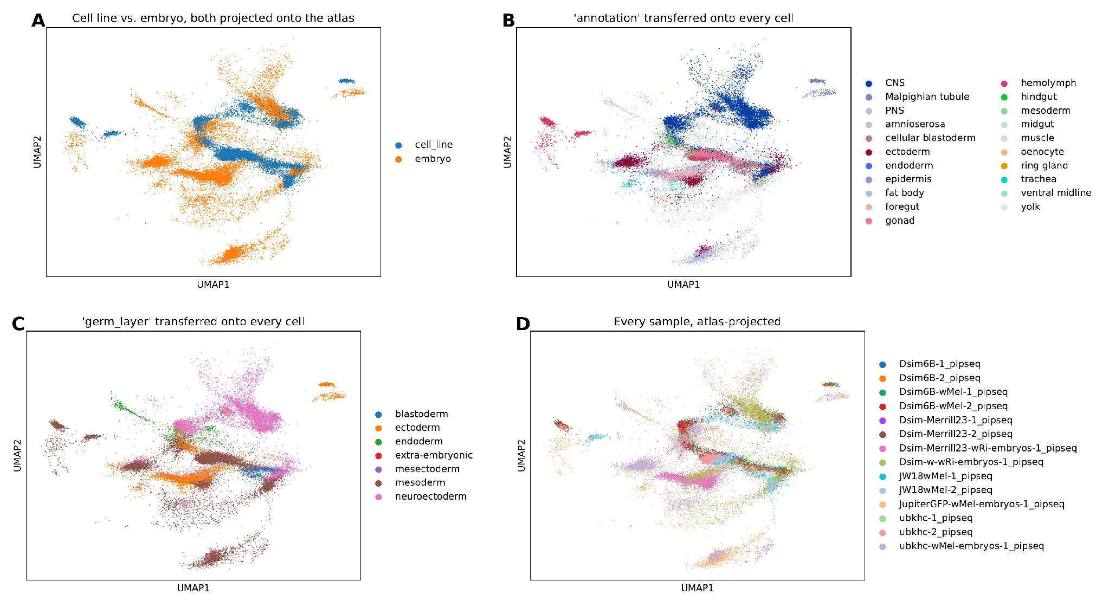
Figure 1. Atlas-projected embedding, colored four ways. (A) Sample type (cell line, blue; embryo, orange). (B) Transferred atlas_annotation. (C) Transferred atlas_germ_layer. (D) Individual sequencing library.

Cell lines converge on a narrow subset of embryonic cell identities
Whole-embryo conditions were compositionally heterogeneous, each spanning 7–16 of the 21 possible atlas cell types with no single type exceeding approximately 65% of cells (mean Shannon diversity H′ = 2.22 at the atlas_annotation resolution; Figure 2). Every cell-line condition, by contrast, was dominated by a small subset of the same three identities, hemolymph-like, gonad-like, and CNS-like, which together accounted for 78–96% of cells in each cell line (mean H′ = 1.53; Figure 2).
Cell lines had lower mean Shannon diversity than embryos at the atlas-annotation resolution (1.53 versus 2.22) and the germ-layer resolution (1.23 versus 1.40), but with four embryo and five cell-line conditions neither difference was significant (exact Mann–Whitney p = 0.11 and 0.41; Table S9), so these data cannot establish that cell lines retain fewer identities. This convergence was independent of genetic background and Wolbachia infection: all five cell lines, spanning two host species (D. simulans and D. melanogaster) and both infected (JW18wMel, Dsim6B-wMel) and uninfected (ubkhc, Dsim6B, Dsim-Merrill23) cell lines, showed the same hemolymph/gonad/CNS-dominated profile. Marker-based scoring (below) does not support the CNS-like label: neural marker states made up at most 3.3% of cell-line cells, which suggests that proliferative cell-line cells project onto the atlas CNS population by nearest-neighbor similarity rather than by neural identity.
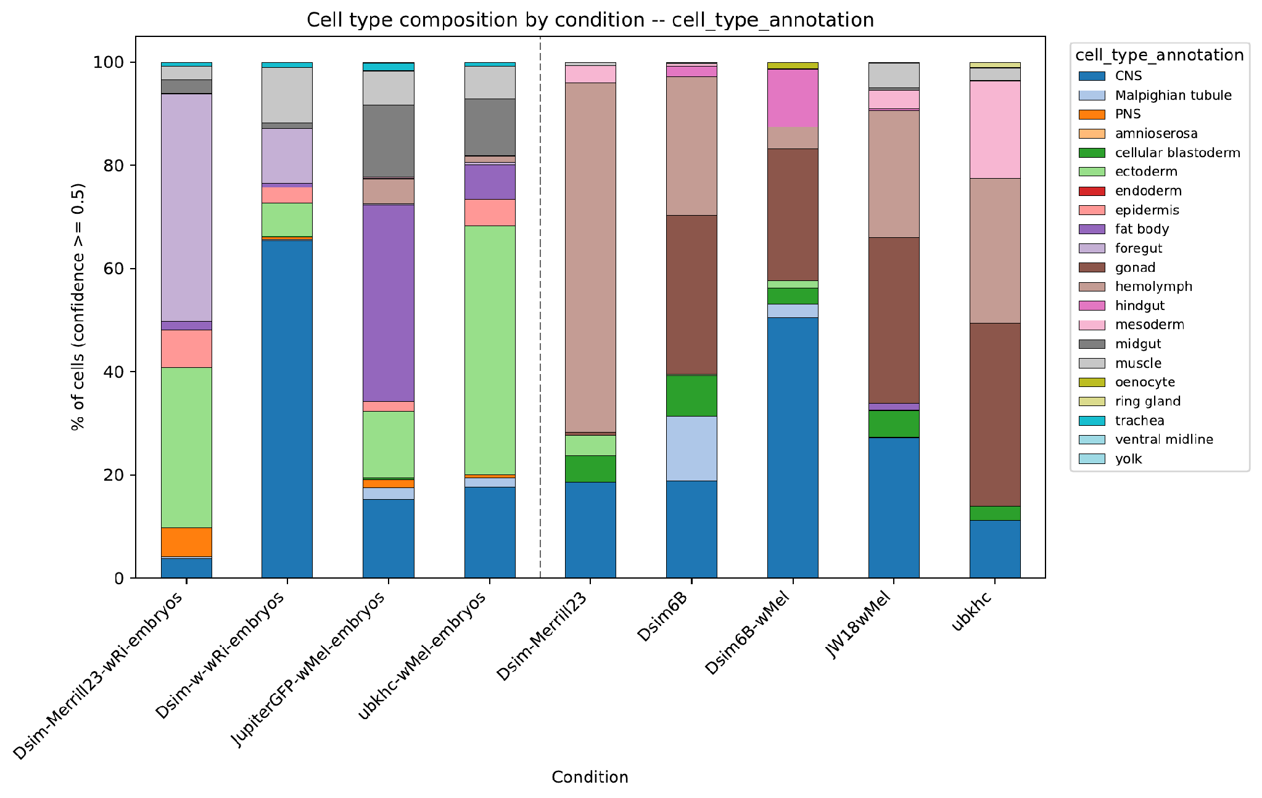
Figure 2. Cell-type composition by condition (atlas_annotation, confidence ≥ 0.5), embryo conditions at left of the dashed line and cell-line conditions at right.

Pseudobulk transcriptomes cluster by culture status rather than by genetic background
Hierarchical clustering of pairwise pseudobulk correlations across all nine conditions produced a top-level split that separated all four embryo conditions from all five cell-line conditions; genetic background and Wolbachia strain structured only the sub-clusters within each group (Figure 3A). The mean pairwise Spearman correlation was 0.842 among cell lines and 0.839 among embryos, compared with 0.731 between a cell line and any embryo condition, regardless of species or Wolbachia strain (permutation test over all 126 embryo/cell-line relabelings of the nine conditions, p = 0.016). Notably, a cell line's pseudobulk profile did not correlate most strongly with that of embryos from its own stock: Dsim6B, for example, correlated more strongly with Dsim-Merrill23-wRi-embryos (ρ = 0.855) than with Dsim-w-wRi-embryos from its own stock (ρ = 0.809). Only JW18wMel and Dsim-Merrill23 correlated best with embryos from their own stock; Dsim6B and Dsim6B-wMel ranked theirs second and ubkhc third of four (Table S10). Culture status was therefore a stronger determinant of pseudobulk transcriptome similarity than either species or the stock from which a cell line was established.

Embryo, but not cell-line, pseudobulk profiles are tissue-specific
Correlating each condition's pseudobulk profile against reference pseudobulk profiles for each atlas tissue (computed from embryo cells only) showed that embryo conditions correlated closely with the tissue matching their dominant annotation, Dsim-Merrill23-wRi-embryos against foregut (ρ = 0.99) and JupiterGFP-wMel-embryos against fat body (ρ = 0.97), for example, whereas cell-line conditions showed uniformly moderate correlations (ρ = 0.65–0.85; Figure 3B). Embryo conditions correlated more strongly than cell lines with their best-matching tissue (mean top ρ 0.97 versus 0.81; exact Mann–Whitney p = 0.016, the smallest attainable for four versus five conditions), but the margin over the second-best tissue did not differ (0.018 versus 0.017; p = 1.0; Table S9). Cell-line transcriptomes therefore resemble every embryonic tissue less, rather than lacking a single best-matching tissue.
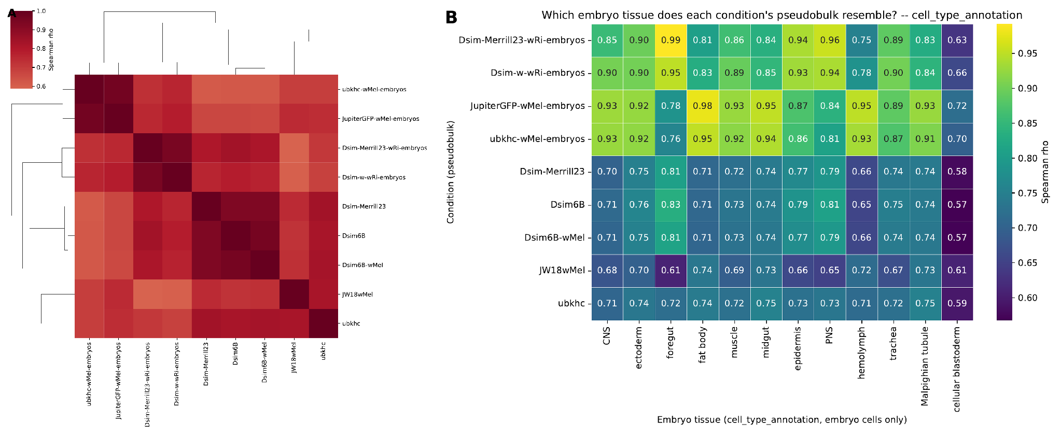
Figure 3. Pseudobulk transcriptome comparisons across conditions. (A) Hierarchical clustering of pairwise Spearman correlations between pseudobulk profiles for all nine conditions. (B) Spearman correlation between each condition's pseudobulk profile (rows) and the reference pseudobulk profile of each atlas tissue computed from embryo cells only (columns).

Embryos, primary cell lines, and cell lines occupy discrete transcriptional states
To compare each stock's embryos with early and long-established cultures, we added one primary-cell-line library per stock (5,892–6,156 cells each), sampled a few weeks after plating, and grouped samples into four lineages by stock: in D. melanogaster, JupiterGFP-wMel embryos, wMel_JupiterGFP primary cell lines, and JW18wMel, and ubkhc-wMel embryos, wMel_Ubkhc primary cell lines, and ubkhc; in D. simulans, Dsim-w-wRi embryos, wRi_Dsimw- primary cell lines, and Dsim6B plus Dsim6B-wMel, and Dsim-Merrill23-wRi embryos, wRi_Merrill23 primary cell lines, and Dsim-Merrill23. The primary cell lines are not the ancestors of the cell lines, which were established from the same stocks years to decades earlier, so the three stages within a lineage are related by stock rather than by descent. We mapped D. simulans genes to their 1:1 D. melanogaster orthologs so that all lineages share one annotation. Within each lineage, we built an embedding from within-sample highly variable genes, excluding ribosomal, mitochondrial, heat-shock, and immediate-early genes. The three stages still separated completely (Figure 5A): in every sample except the 224-cell Dsim-Merrill23 embryo library, at least 99.4% of each cell's nearest neighbors came from the same stage (94.6% for that library). Because no intermediate cells connected the stages, a continuous pseudotime could only restate this three-step separation, so we compared the stages with pseudobulk differential expression instead, treating the four lineages as biological replicates (PyDESeq2; design ~ lineage + stage).

Stage differences are shared across species and lineages
A few weeks of primary culture changed 4,484 genes (2,125 up and 2,359 down in primary cell lines; adjusted p < 0.05), and cell lines differed from primary cell lines at 3,720 genes (287 up and 3,433 down in cell lines). All four lineages agreed in direction for 81% and 84% of these genes, respectively (12.5% expected by chance; binomial p < 10⁻¹⁰⁰ for both), and a species-by-stage interaction affected only 195 genes in the primary-cell-line-versus-cell-line comparison. Primary cell lines were sequenced more deeply than embryos or cell lines, so we repeated the analysis after downsampling every cell to 2,000 UMIs; this retained 89–97% of significant genes per contrast, with log2 fold-change correlations of at least 0.99, so sequencing depth did not drive these differences.
Gene set enrichment analysis separated the two comparisons (Figure 5B). Relative to embryos, primary cell lines up-regulated proteasome, endosomal transport, DNA repair, and Toll and Imd signaling genes (normalized enrichment scores 2.2–2.6; FDR ≤ 0.003) and down-regulated translation and developmental programs (axon guidance, nervous system, eye, and imaginal disc development; NES −2.4 to −3.1; FDR < 0.001). Relative to primary cell lines, cell lines up-regulated peptide biosynthesis, ribosome biogenesis, DNA replication, and mitotic spindle organization (NES 3.7–5.5; FDR < 0.001) and down-regulated antibacterial defense and differentiation terms (defense response to Gram-positive bacteria, neuroblast differentiation, muscle cell fate commitment, stem cell development; NES −1.8 to −1.9; FDR 0.007–0.035; Table S3).
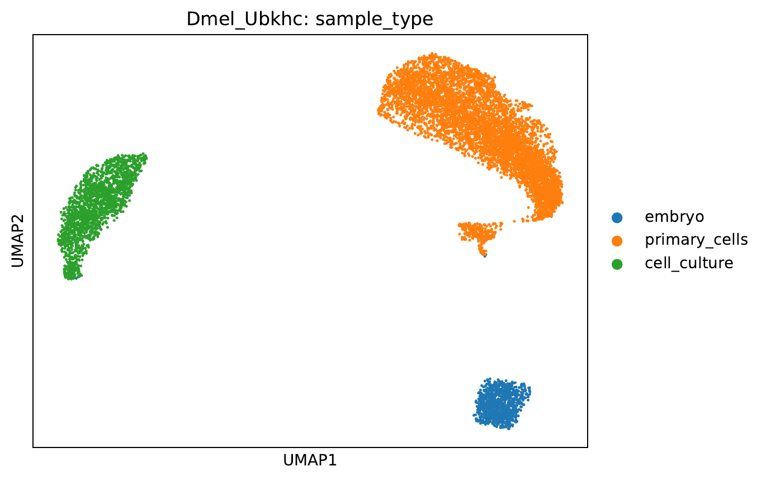
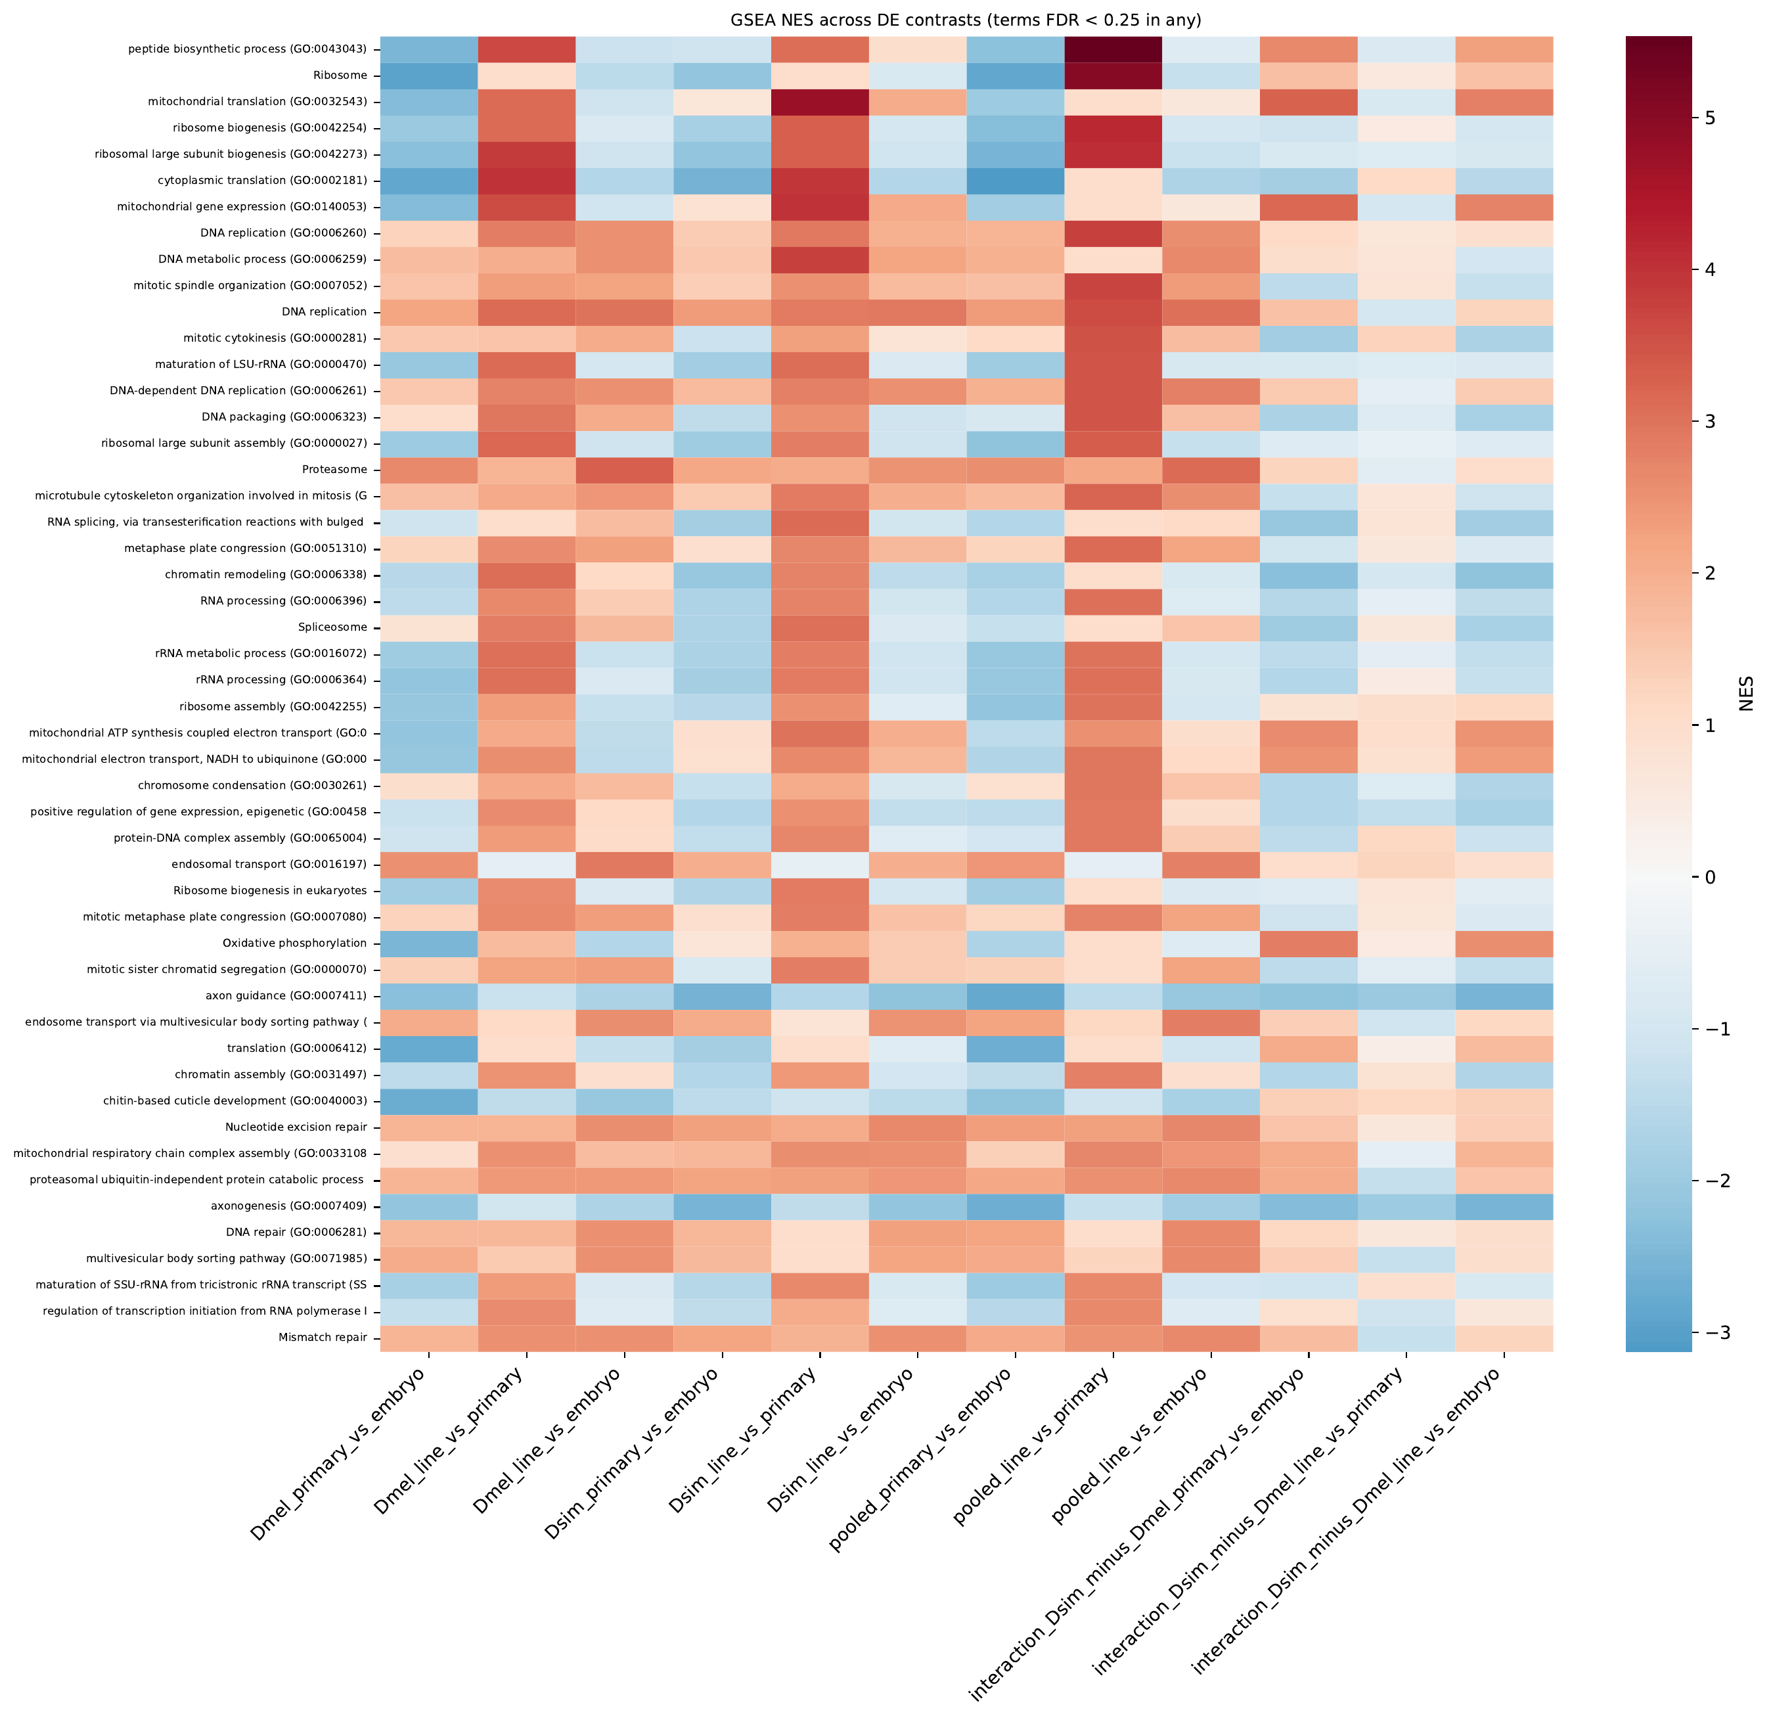
Figure 5. Stage structure and shared stage differences. (A) Per-lineage embedding for Dmel_Ubkhc colored by stage (embryo, primary cell line, cell line); the other three lineages show the same complete separation. (B) Normalized enrichment scores for GO Biological Process and KEGG terms across per-species, pooled, and species-interaction contrasts (terms with FDR < 0.25 in any contrast).

Marker-based cell states show that cell lines are proliferative and lack the injury program of primary cell lines
Because the atlas labels come from intact embryos, we also scored every cell for curated marker modules (plasmatocyte, crystal cell, lamellocyte, fat body, neural, neuroblast, muscle, epidermis, germline, proliferation, and antimicrobial peptides; Figure 6). We tested each stage comparison with lineages as replicates (paired t-test on the per-lineage log odds of each state, n = 4; BH-adjusted across 24 tests; Table S4). Proliferating cells made up 0.5–6.2% of embryo cells and 0.1–10.5% of cells in primary cell lines but 27–66% of cell-line cells (mean log odds ratio 3.6 for cell line versus primary cell line; p = 0.044, adjusted p = 0.08). An antimicrobial-peptide program marked 17–69% of cells in primary cell lines and was absent from embryos and cell lines (p = 0.004 and 0.003; adjusted p = 0.019 for both), which suggests that dissociation and culture trigger an injury or immune response that established cell lines no longer carry. Fat-body-like states followed the same pattern (0% in embryos, 16–33% in primary cell lines, ≤0.6% in cell lines; adjusted p = 0.019 and 0.045). Crystal-cell states, present in 12–13% of cells in primary cell lines, fell to 0–1.4% in cell lines (p = 0.043; adjusted p = 0.08). Plasmatocyte-like states rose from 0–2.7% in embryos to 4–16% in primary cell lines (adjusted p = 0.019) and reached 62% of ubkhc, 35% of Dsim-Merrill23, and 32% of the Dsim_w cell lines, but JW18wMel was only 4% plasmatocyte-like (54% unassigned, 25% neuroblast-like), so the cell-line versus primary-cell-line difference was not significant (p = 0.23). With four lineages, these tests have limited power; the directions were consistent in every lineage for proliferation, the antimicrobial-peptide program, and crystal-cell states.
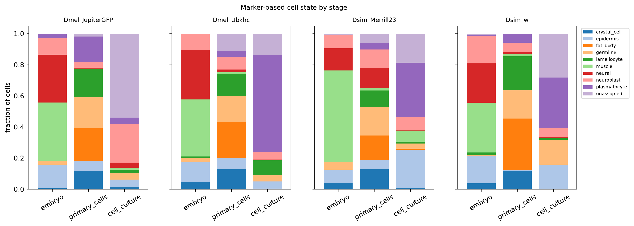
Figure 6. Marker-based cell state by stage for each lineage. Each cell is assigned to the identity module with the highest z-scored module score (z > 0.5; otherwise unassigned).

Proliferating cells in primary cell lines partly resemble cell lines
To ask whether any primary-cell-line subpopulation resembles the cell lines, we compared the 5% of cells with the highest proliferation scores in each primary cell line with the remaining cells and correlated their per-gene expression shift with the pseudobulk log2 fold change between cell lines and primary cell lines (Spearman ρ), using only genes outside the highly variable set. We compared each ρ with 2,000 random equal-sized sets of cells from the same primary cell line and, separately, with random sets matched on per-cell sequencing depth, and adjusted p-values across all 36 rank tests (Benjamini–Hochberg). Proliferative cells shifted toward the cell line in both D. melanogaster lineages and in Dsim_w (ρ = 0.25–0.32; adjusted p = 0.003, 0.003, and 0.015; Figure 7; Table S5). The shift persisted after we removed 415–476 cell-cycle, ribosome-biogenesis, translation, and chromatin genes (ρ = 0.24–0.31) and after we also removed mitochondrial and respiration genes (ρ = 0.25–0.32; adjusted p ≤ 0.016 for all), and it exceeded depth-matched random sets in all three lineages (adjusted p < 0.001). In Dsim-Merrill23, proliferative cells did not shift toward the cell line (ρ = −0.04; adjusted p = 1.0). They exceeded depth-matched sets (adjusted p < 0.001), but only because the depth-matched sets shifted strongly away from the cell line (mean ρ −0.40), so we do not count this lineage as supporting the shift. Cells with the lowest antimicrobial-peptide scores did not shift toward the cell line (ρ = −0.13 to 0.14; adjusted p ≥ 0.20), so reduced injury signaling alone does not explain the effect. Cells selected for global similarity to the cell-line centroid had low sequencing depth (median UMIs 0.34–0.81 times the rest of the primary cell line) and shifted away from the cell line, a depth artifact, so we did not analyze them further. The high-proliferation cells are the upper tail of a continuous, unimodal distribution of proliferation scores rather than a discrete cycling population. Scored on the same scale as each lineage's embryos and cell line, few primary-cell-line cells reached cell-line levels of cell-cycle gene expression: 0.4% of Dsim_w, 0.7% of Dmel_Ubkhc, and 9.1% of Dmel_JupiterGFP primary-cell-line cells exceeded the median cell-line cell (33% in Dsim-Merrill23, whose cell line has the lowest proliferation score of the four). The shift toward the cell line therefore belongs to the cells with the highest cell-cycle gene expression in each culture, not necessarily to cells that were dividing when sampled.
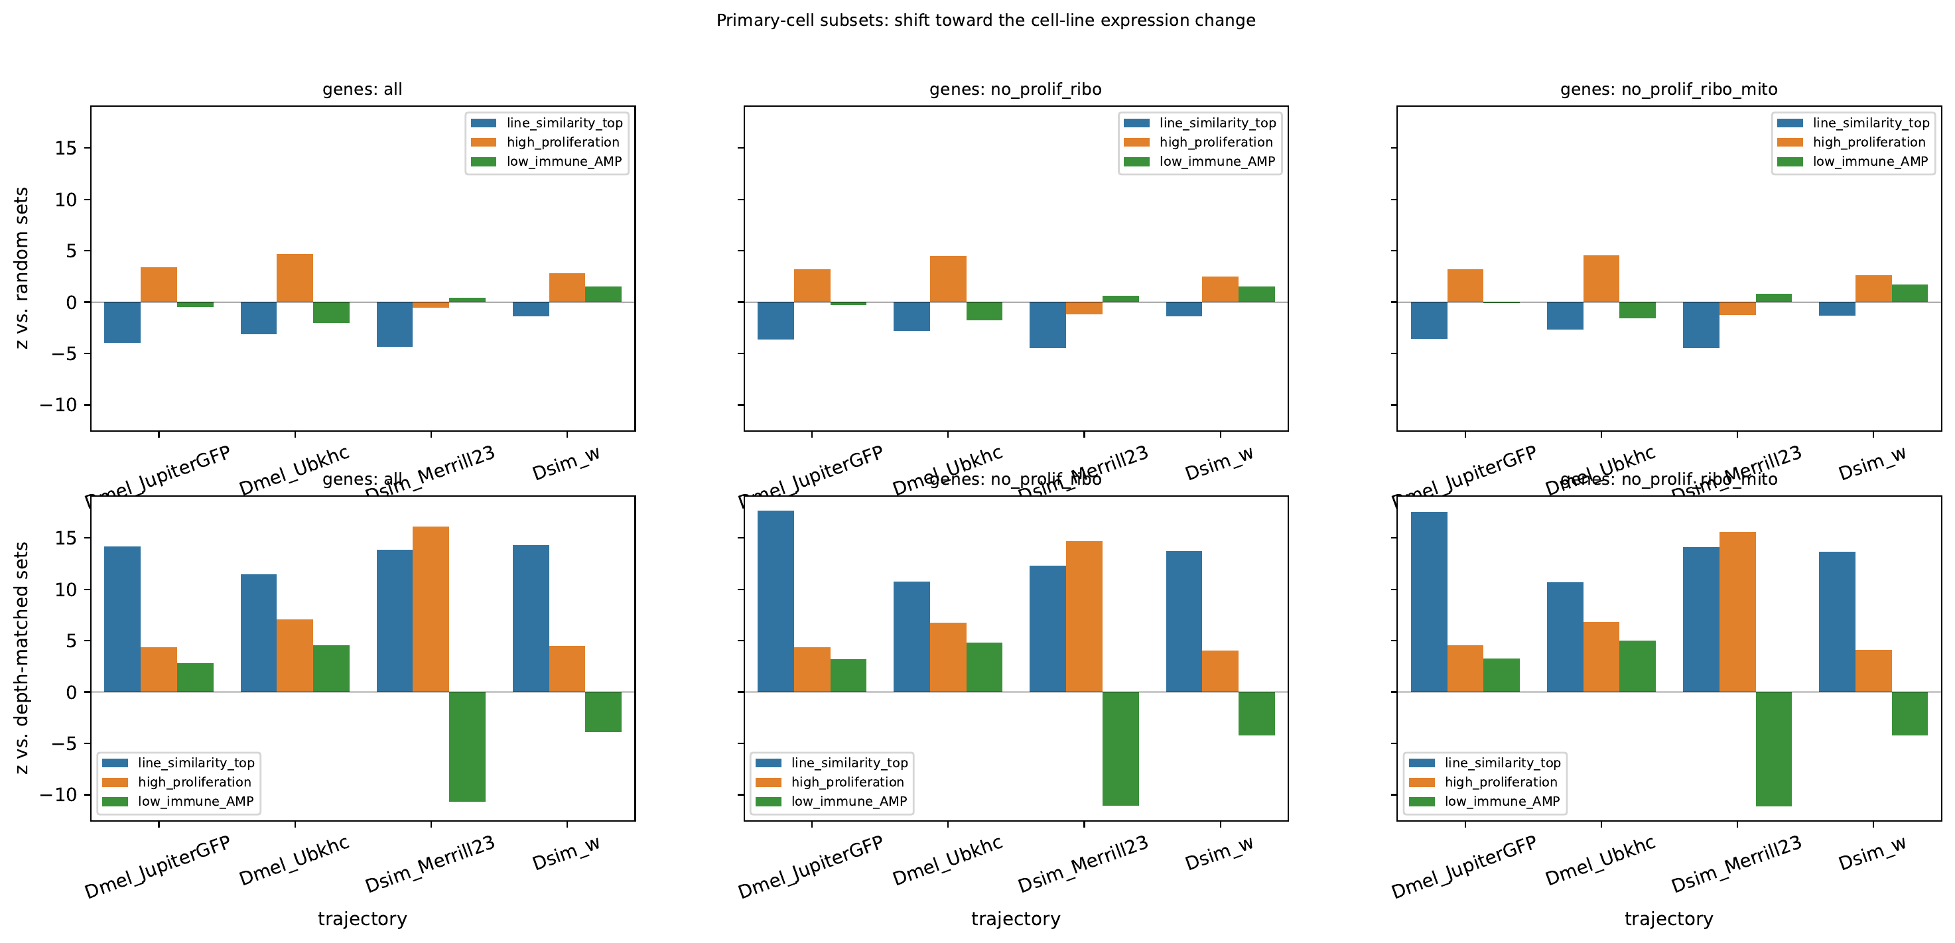
Figure 7. Primary-cell-line subsets tested for a shift toward the cell-line expression change. Bars show z-scores against random equal-sized sets of cells from the same primary cell line (top) and depth-matched random sets (bottom) for three gene sets: all non-highly-variable genes, without proliferation and ribosome-biogenesis genes, and additionally without mitochondrial genes. Candidate sets: top 5% by similarity to the cell-line centroid, top 5% by proliferation score, and bottom 5% by antimicrobial-peptide score. z-scores use 2,000 permutations.

Cell lines lose tissue programs rather than gain new ones
Of the genes expressed in every primary cell line (log2 CPM ≥ 3), 166 were absent (log2 CPM < 1) from every cell line, whereas no gene showed the reverse pattern, and only 46 genes rose consistently in all four lineages (Table 1). The cell lines silenced the Hox genes lab, Dfd, Scr, Antp, Ubx, abd-A, and Abd-B (for example, Antp log2 fold change −8.4, Ubx −8.3, abd-A −8.7) and homothorax (−7.4), together with positional and lineage transcription factors (sna, wor, ase, pros, esg, Dll, ey, cas, gcm, and svp, −10.3). They lost the crystal-cell program (lz −8.5, PPO1 −12.2, PPO2 −11.0), paracrine ligands (dpp −4.0, Actβ −6.8, Ilp6 −2.8, upd1 −3.6), and ecdysone-response genes (Hr3 −4.3, ImpL1 −5.8, E93 −3.9) while retaining EcR. They also silenced the pro-apoptotic genes grim (−6.4) and sickle (−6.1) and the Bcl-2 family gene Buffy (−3.1). The consistently gained genes were mostly mitotic regulators (stg +2.0, CycB +1.3, Incenp, BubR1), while the endocycle switch fzr decreased (−2.1). All log2 fold changes in this section have adjusted p < 0.05 (Table 1; full results in Table S2).
Table 1. Selected genes from the shared stage transitions. Values are pooled log2 fold changes (PyDESeq2, four lineages as replicates, design ~ lineage + stage); every line-versus-primary value shown has adjusted p < 0.05. The full gene panel is in results/pseudotime/mechanisms/pathway_panels.csv.
Gene | Program | Primary cell line vs embryo | Cell line vs primary cell line
Pvr | Receptor tyrosine kinase | −0.2 | +1.3
Pvf2 | PVR ligand | +2.2 | +1.2
Egfr | Receptor tyrosine kinase | −2.3 | −6.3
htl | Receptor tyrosine kinase | −1.0 | −6.8
sty | MAPK feedback target | −2.0 | +1.7
pnt | MAPK feedback target | 0.0 | +1.5
kek1 | MAPK feedback target | −0.9 | +1.4
Orct2 | PI3K growth effector | −0.4 | +1.9
stg | Mitosis (Cdc25) | −1.7 | +2.0
fzr | Endocycle switch | +0.3 | −2.1
Antp | Hox | −3.0 | −8.4
Ubx | Hox | −3.7 | −8.3
abd-A | Hox | −3.3 | −8.7
hth | Hox cofactor | −4.9 | −7.4
svp | Temporal/lineage TF | −0.5 | −10.3
lz | Crystal-cell TF | +3.2 | −8.5
PPO1 | Crystal-cell effector | +4.0 | −12.2
dpp | Paracrine ligand | −2.0 | −4.0
Actβ | Paracrine ligand | −0.1 | −6.8
Hr3 | Ecdysone response | −6.5 | −4.3
Eip93F (E93) | Ecdysone response | +2.5 | −3.9
grim | Pro-apoptotic (H99) | −3.2 | −6.4
skl | Pro-apoptotic (H99) | −2.5 | −6.1
Buffy | Bcl-2 family | −2.0 | −3.1

Silenced developmental regulators are Polycomb targets in embryos and in established cell lines
To test whether the silenced genes are Polycomb targets, we measured the fraction of each gene body covered by embryonic H3K27me3 domains and by Polycomb-repressed chromatin in S2 and BG3 cells (modENCODE 9-state model, state 6); all eight Hox genes were marked in all three maps. Genes switched off in every cell line were strongly enriched for Polycomb marking relative to unchanged genes (Figure 8): 19.8% versus 1.3% for embryonic H3K27me3 (odds ratio adjusted for gene length and primary-cell-line expression, 9.3), 7.8% versus 0.16% for the BG3 Polycomb state (40), and 7.5% versus 0.08% for the S2 Polycomb state (72; all p < 0.001). Consistently down-regulated genes showed weaker enrichment (adjusted odds ratios 5.7–13; Table 2), and among all genes that decreased, each log2 unit of decrease raised the odds of marking 1.29-fold for embryonic H3K27me3, 1.36-fold for BG3, and 1.43-fold for S2 (logistic regression adjusted for gene length and expression; p < 10⁻¹⁶ for all). Most switched-off genes (263 of 333) were unmarked in all three maps; these were enriched for neuropeptide signaling (6 of 14 genes; adjusted p = 0.001), proteolysis (13 of 112; adjusted p = 0.018), and chemosensory perception (7 of 39; adjusted p = 0.035), whereas the 70 marked switched-off genes were enriched for imaginal-disc and genital-disc patterning terms (Abd-B, abd-A, Antp, dac, Lim1, disco; adjusted p = 0.002–0.011; hypergeometric test, BH-adjusted). Polycomb marking therefore separates the developmental regulators that cell lines silence from the terminal effector genes they switch off without the mark. The 20 genes marked in all three maps included developmental regulators such as Antp, abd-A, Abd-B, svp, lz, fkh, disco, dac, sv, Drgx, and Dr, and marked down-regulated genes included SoxN, mirr, grh, kn, TfAP-2, Kr, hth, pros, esg, dpp, hh, and Wnt4. These loci were therefore Polycomb targets before culture and sit in Polycomb chromatin in two unrelated established cell lines.
Table 2. Polycomb marking by gene group. Percentage of genes with at least 50% of the gene body in each map; odds ratio versus unchanged genes adjusted for gene length and primary-cell-line expression (logistic regression). Gene groups include only genes expressed in every primary cell line.
Gene group (n) | Embryo H3K27me3 | BG3 Pc state | S2 Pc state
Off in all cell lines (333) | 19.8% (OR 9.3; p < 0.001) | 7.8% (OR 40; p < 0.001) | 7.5% (OR 72; p < 0.001)
Consistently down (697) | 10.9% (OR 5.7; p < 0.001) | 3.3% (OR 10; p < 0.001) | 2.6% (OR 13; p < 0.001)
Consistently up (46) | 4.3% (OR 2.7; p = 0.20) | 2.2% (OR 10; p = 0.04) | 0% (n.s.)
Unchanged (3,862) | 1.3% (reference) | 0.16% (reference) | 0.08% (reference)

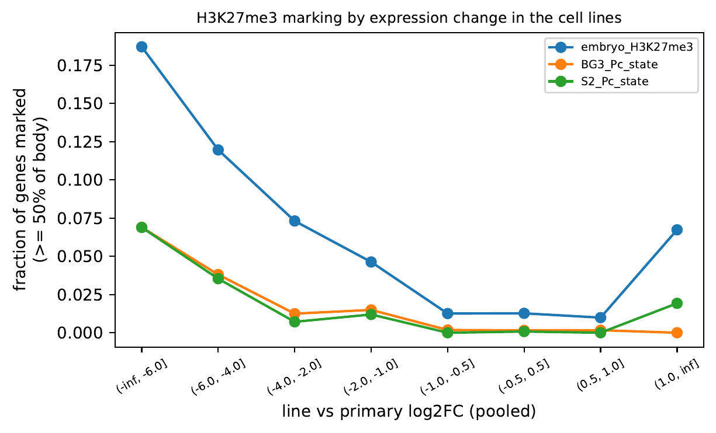
Figure 8. Fraction of genes with at least 50% of the gene body in H3K27me3 (embryo) or Polycomb-state chromatin (BG3, S2), binned by pooled log2 fold change between cell lines and primary cell lines. Only genes expressed in every primary cell line are included.

Culture-emergent differences between the species
D. simulans embryos establish cell lines more readily than D. melanogaster embryos in our hands, so we looked for genes that separate the species only after culture. Because the D. simulans embryo samples differ from D. melanogaster embryos in ecdysone-cascade genes, which suggests a difference in developmental stage, we did not use the species-by-stage interaction. Instead, we selected genes whose embryo expression differed by at most 1 log2 CPM between species but whose expression in every D. simulans primary cell line exceeded that in every D. melanogaster primary cell line (or the reverse) by at least 1.5 log2 CPM, using pseudobulk values averaged within each lineage. Fifty-six genes were higher in D. simulans and 88 in D. melanogaster, and the difference persisted by at least 1 log2 CPM in every cell line, including the uninfected ones, for 32 and 28 of them (Table S12). Persistent D. simulans-high genes included the translation initiation factor eIF4E6, the replisome component Ctf4, the lysosomal cystine transporter Ctns, and the coenzyme Q biosynthesis gene Coq3. Persistent D. melanogaster-high genes included adhesion and cytoskeletal genes (cno, Fas2, dia, ssh, msps, hbs), the tyrosine phosphatases Ptp4E and Ptpmeg, Mmp1, and Enhancer of Polycomb. Because D. simulans reads were assigned to D. melanogaster genes through 1:1 orthologs, each candidate needs its gene model and read coverage checked before functional tests; the largest differences, such as Gns (5.6 log2 CPM), are the most likely to reflect mapping differences.

Cells switch from EGFR to PVR signaling in culture, and D. simulans cell lines lose the Spitz-processing gene Star
Key finding. Cells switch from EGFR to PVR signaling in culture. Egfr is nearly absent from every cell line, while Pvr and its ligand Pvf2 rise and Pvr, not Egfr, tracks MAPK target expression. The species differ in how the EGFR side is dismantled: D. simulans cell lines express about 3-fold less of the Spitz-processing gene Star than D. melanogaster cell lines (31–37 versus 97–101 CPM), and D. simulans primary cell lines express about 8-fold less of the receptor tyrosine phosphatase Ptp4E, a difference absent from the embryos. The Dsim_Merrill23 primary cell line had already lost most Egfr (10% of its embryo level), whereas the other three primary cell lines retained it (Figure 11).
The cell lines lost nearly every receptor tyrosine kinase expressed in primary cell lines, including Egfr (−6.3), htl (−6.8), Drl-2 (−6.7), otk (−6.0), sev (−4.1), and btl (−2.6). Pvr, the PDGF/VEGF receptor homolog, was the only receptor tyrosine kinase that increased (+1.3 in all four lineages), and its ligand Pvf2 rose in primary cell lines (+2.2) and stayed expressed in cell lines. Classic MAPK feedback targets increased despite the loss of EGFR (sty +1.7, pnt +1.5, kek1 +1.4, CG6006 +1.4, all four lineages; Mkp3 +1.0, pooled), as did the PI3K growth effector Orct2 (+1.9, all four lineages). Within single cells, Pvr expression correlated weakly with a MAPK target score after controlling for sequencing depth (ρ positive in 16 of 18 samples, sign test p = 0.001; up to 0.24, and 0.06–0.24 in cell lines except the 126-cell ubkhc-1 library; Figure 9; Table S6). Pvr-positive cells in primary cell lines had higher MAPK scores than Pvr-negative cells in three lineages (difference +0.04 to +0.06; Mann–Whitney p < 0.001) and lower scores in Dmel_Ubkhc (−0.06; p < 0.001). Pvr did not correlate with proliferation (ρ −0.07 to 0.16 across samples), and the most proliferative cells in primary cell lines were not consistently Pvr-high (Pvr difference +0.05, p = 0.02; −0.11, p < 0.001; +0.08, p < 0.001; −0.06, p = 0.02, for Dmel_JupiterGFP, Dmel_Ubkhc, Dsim_Merrill23, and Dsim_w), so PVR signaling marks established cell lines rather than the proliferative cells in primary cell lines that resemble them.
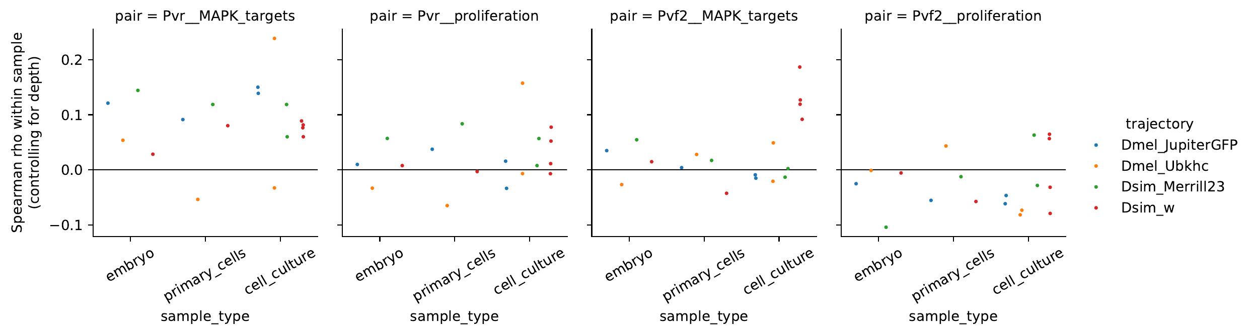
Figure 9. Within-sample Spearman correlations, controlling for per-cell UMI depth, between Pvr or Pvf2 expression and the MAPK target score (sty, pnt, kek1, Mkp3, aos, CG6006) or the proliferation score, by stage and lineage.
To resolve when and in which cells the switch occurs, we classified every cell by whether it detected Egfr, Pvr, both, or neither, and compared stages within each lineage (Figure 10; Table S14). Egfr fell from 105–268 CPM in embryos to 0–3 CPM in cell lines, where fewer than 1% of cells detected it, whereas Pvr rose from 42–214 to 293–635 CPM. Primary cell lines were intermediate: the fraction of Pvr-only cells rose in every lineage after a few weeks in culture (odds ratio 2.2 to 40; Fisher p < 10⁻²⁴), Pvf2 rose from 9–17 to 49–132 CPM, and most primary cell lines still expressed Egfr (10–111 CPM). The species differed in how the EGFR side was dismantled (described below).
Within primary cell lines, the two receptors marked different cells. Pvr-only cells scored higher than Egfr-only cells for plasmatocyte genes (+0.28 to +0.43 z in three lineages, adjusted p < 0.05; +0.20 in Dmel_Ubkhc, not significant) and lower for neural, muscle, and fat-body genes, although 88 to 98% of both classes mapped to atlas mesoderm. A ligand-receptor permutation test (mean ligand in the sender state times mean receptor in the receiver state; 2,000 permutations; BH-adjusted) found 155 significant sender-receiver pairs in primary cell lines. Plasmatocyte-like cells were the most frequent receivers of Pvf1–3 (33 of 69 pairs), and fat-body-like cells were the most frequent receivers of spi, Krn, vn, and grk (43 of 86 pairs).
Pvr-positive cells detected a Pvf ligand more often than Pvr-negative cells after adjusting for depth in two primary cell lines (odds ratio 1.47 and 1.29; adjusted p ≤ 0.002), but Egfr-positive cells co-expressed EGFR ligands to the same degree (1.44 and 1.38), so co-expression does not specifically indicate an autocrine PVR loop. In cell lines, nearly every Pvr-positive cell expressed Pvf2 (99% in Dsim6B), which permits an autocrine loop but leaves no contrast to test. The proliferative cells in primary cell lines were depleted of Egfr (depth-adjusted odds ratio 0.53 to 0.66; p < 0.01 in the three lineages with enough proliferative cells to test) but not enriched for Pvr (detected in 61%, 86%, and 75% of proliferative cells versus 63%, 91%, and 76% of other cells), so losing Egfr, rather than gaining Pvr, distinguishes them. Egfr expression did not track the MAPK target score in any sample (|ρ| ≤ 0.08), and the EGFR-biased target argos did not track a MAPK score built without it (ρ = −0.08 to 0.11), consistent with little EGFR activity in culture. The exception was the infected Dsim6B-wMel cell line, where argos tracked the score weakly (ρ = 0.09 and 0.11; p ≤ 10⁻⁴), whereas it did not in the cured Dsim6B line (ρ = 0.01 and 0.03).
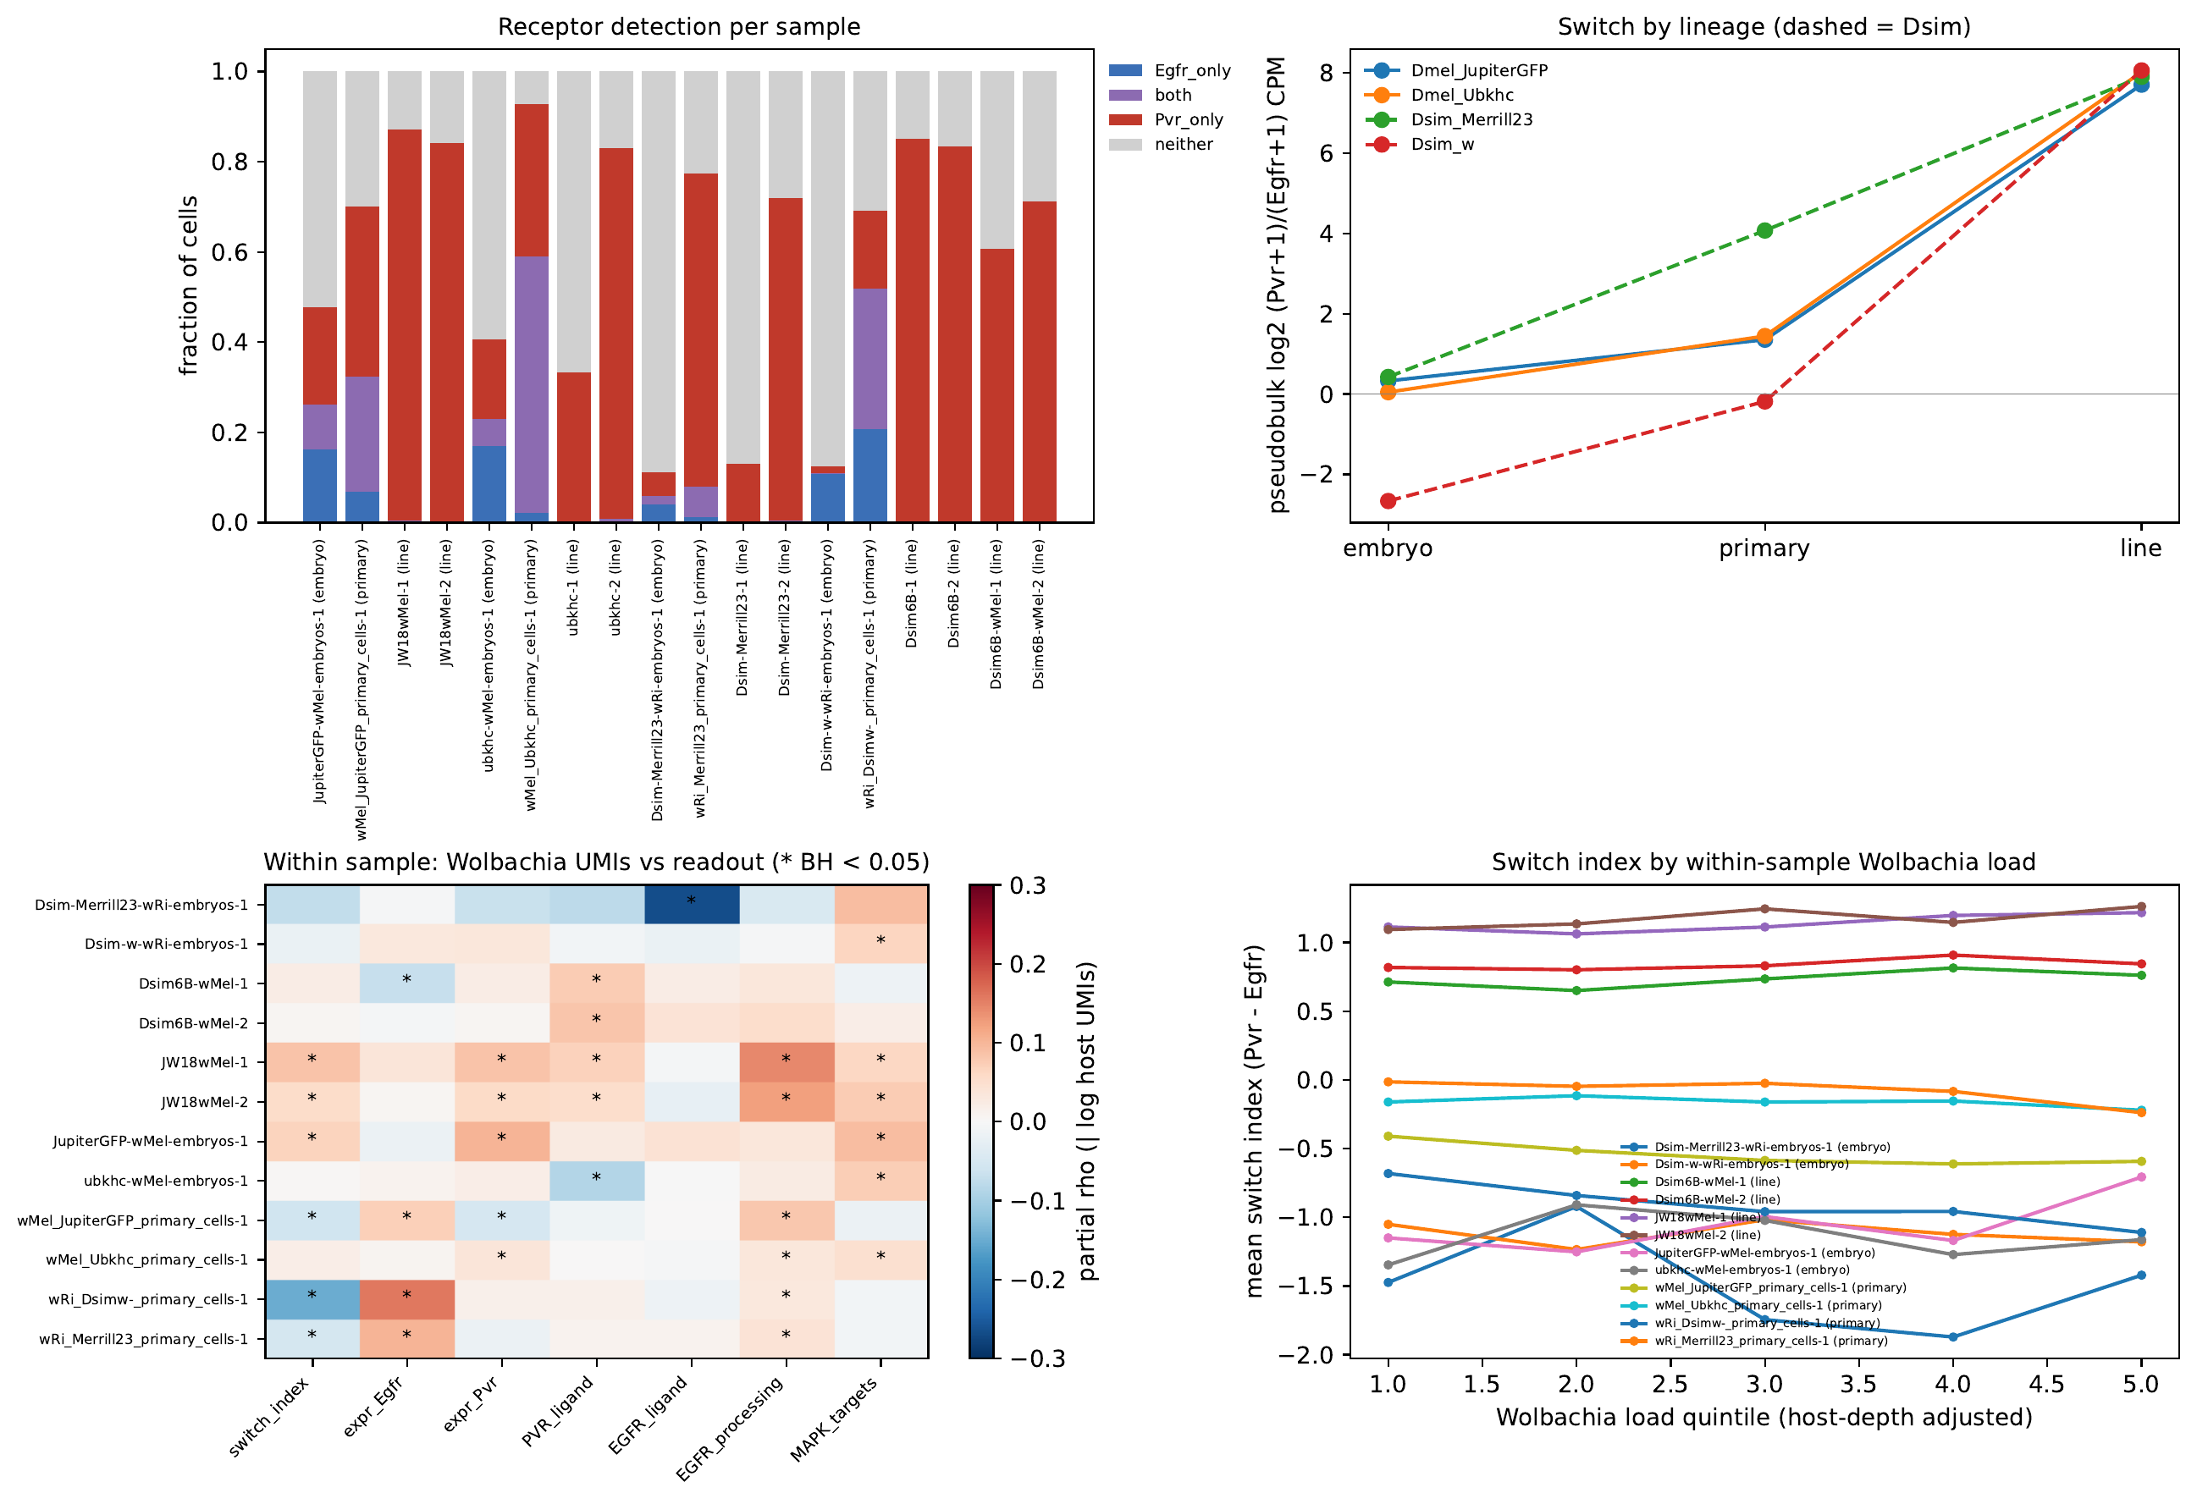
Figure 10. Egfr-to-Pvr switch. (A) Fraction of cells detecting Egfr only, Pvr only, both, or neither (one or more UMIs) in each library. (B) Pseudobulk log2 (Pvr + 1)/(Egfr + 1) CPM by stage and lineage; dashed lines, D. simulans. (C) Within-sample partial Spearman correlations between Wolbachia UMIs and the switch score (z Pvr minus z Egfr), receptor, ligand, ligand-processing, and MAPK readouts, controlling for host UMIs, in libraries with a median of at least 5 Wolbachia UMIs per cell (* BH-adjusted p < 0.05). (D) Mean switch score by within-sample Wolbachia load quintile (load adjusted for host UMIs).
The species differed in how cells dismantled the EGFR side of the switch (Figure 11). D. simulans embryos differ from D. melanogaster embryos in ecdysone-cascade genes and also in Pvr (−1.3 log2 CPM), Star (+0.9), and rho (+1.1), so we compared absolute expression at each stage rather than change from the embryo, which would overstate the D. simulans changes for these genes. At the primary stage, only Dsim_Merrill23 stood apart: it retained 10% of its embryonic Egfr (10 CPM) and had the highest Pvr-to-Egfr ratio (log2 4.1), whereas Dsim_w retained D. melanogaster-like Egfr (102 CPM versus 50 and 111 CPM) and a lower ratio (−0.2 versus 1.4 in both D. melanogaster primary cell lines). Star was similar across species in primary cell lines (54–84 versus 82–86 CPM) but diverged in cell lines: D. melanogaster cell lines kept Star near embryonic levels (97–101 CPM versus 115 CPM in embryos), whereas the uninfected D. simulans cell lines expressed 31–37 CPM. Star traffics the Spitz precursor to Rhomboid for cleavage (Lee et al. 2001; Tsruya et al. 2002) and was the only gene in the EGFR and PVR pathway panel with a significant species-by-stage interaction (cell line versus embryo, log2 fold change −2.2, adjusted p = 0.016; Table S14), although the higher Star of D. simulans embryos contributes to that estimate. The embryo-matched screen for culture-emergent species differences (Table S12) did not select Egfr, Pvr, the Pvf genes, Star, or rho, but it did select two tyrosine phosphatases and a Ras-binding protein: D. simulans primary cell lines expressed about 8-fold less of the receptor tyrosine phosphatase Ptp4E (3.2–3.5 versus 6.2–6.5 log2 CPM; embryo difference −0.9), less of the cytoplasmic phosphatase Ptpmeg (4.2–4.4 versus 6.4–6.6), and less of the Ras- and Rap1-binding junction protein canoe (3.4–3.5 versus 6.4), and all three stayed lower in D. simulans cell lines. MAPK targets such as sty and pnt reached similar levels in both species' cell lines (within 1 log2 CPM). The infected Dsim6B-wMel line was the exception among D. simulans cell lines, expressing Star at D. melanogaster levels (91 CPM; +1.4 log2 versus cured Dsim6B).
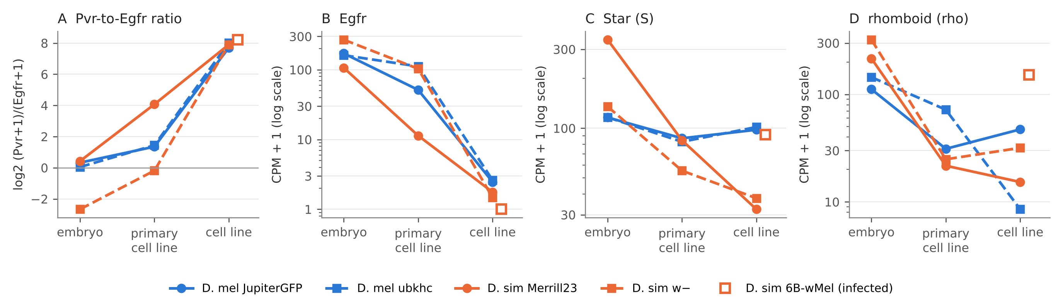
Figure 11. EGFR signaling components by species and stage. Pseudobulk expression by stage for each lineage (blue, D. melanogaster; orange, D. simulans; replicate libraries averaged). (A) log2 (Pvr + 1)/(Egfr + 1) CPM. (B–D) Egfr, Star, and rhomboid, CPM + 1 on a log scale. The D. simulans w− cell-line point is the cured Dsim6B line; the open square is the infected Dsim6B-wMel line. D. simulans embryos differ from D. melanogaster embryos in Pvr, Star, and rho, so compare absolute levels between species at each stage.

Wolbachia titer differs across transferred cell types, but the pattern reflects three uninfected cell lines
Wolbachia titer differed significantly across the 20 transferred atlas cell types represented in the dataset (Kruskal–Wallis test, H = 3942.46, df = 19, p < 0.0001; Figure 4A). Given the sample size (n = 35,921 cells), this threshold was readily exceeded even for small effects, so we examined the underlying pattern directly. Infection frequency (titer > 0) exceeded 96% in nearly every differentiated tissue category (ectoderm, foregut, midgut, muscle, fat body, PNS, trachea, epidermis, yolk) but fell markedly in categories that were disproportionately composed of cell-line cells: hemolymph (42% infected), mesoderm (37%), ring gland (37%), Malpighian tubule (41%), cellular blastoderm (54%), and gonad (60%). Stratifying mean titer jointly by cell type and condition showed that this pattern came from three uninfected cell lines (Figure 4B): ubkhc and Dsim-Merrill23, which lost their wMel and wRi infections during culture, and Dsim6B, which we cured of wRi with doxycycline. In these cell lines, Wolbachia genes accounted for at most 0.02% of UMIs, consistent with ambient RNA, compared with 1.0–3.7% in embryos, 0.3–3.3% in primary cell lines, 4.9–5.3% in JW18wMel, and 3.0–3.2% in Dsim6B-wMel. The cell-type effect on titer therefore reflects which cell lines are infected rather than cell identity. Dsim6B-wMel, JW18wMel, and all four embryo conditions remained 96–100% infected across nearly every cell type.
Dsim6B-wMel and Dsim6B offered a direct comparison of an infected cell line with a doxycycline-cured cell line of the same origin, since both derive from wRi-infected D. simulans w− flies (two libraries each, so the replicate variance estimate is limited). The two cell lines differed at 4,783 genes (adjusted p < 0.05; Table S8). The infected cell line up-regulated the pro-apoptotic genes reaper (+4.4) and hid (+3.2) and the JAK/STAT stress genes upd3 (+1.4) and Socs36E (+1.4; adjusted p < 10⁻²⁰ for all four), and apoptosis, autophagic cell death, Hippo regulation, and glutathione metabolism terms (NES 1.8–2.2; FDR 0.003–0.023), and it down-regulated ribosome biogenesis, mitotic nuclear division, and fatty acid β-oxidation (NES −2.2 to −2.4; FDR ≤ 0.002; Figure S1). Infection-associated changes barely tracked the cell-line-versus-primary-cell-line program (ρ = 0.06 across 8,305 genes, p = 3 × 10⁻⁸; ρ = 0.08 across 1,066 cell-line-program genes, p = 0.006). However, Dsim6B-wMel expressed white (log2 CPM 6.2 versus 0–0.3 in Dsim6B and about 1.4 in the D. simulans w− embryo and primary cell line) and had lost plasmatocyte and basement-membrane genes that Dsim6B expresses (Hml, Pxn, Col4a1, vkg), so the two cell lines differ in cell identity, and possibly genotype, as well as infection. Doxycycline also inhibits mitochondrial translation, so the cured line may carry treatment effects in addition to the loss of Wolbachia.
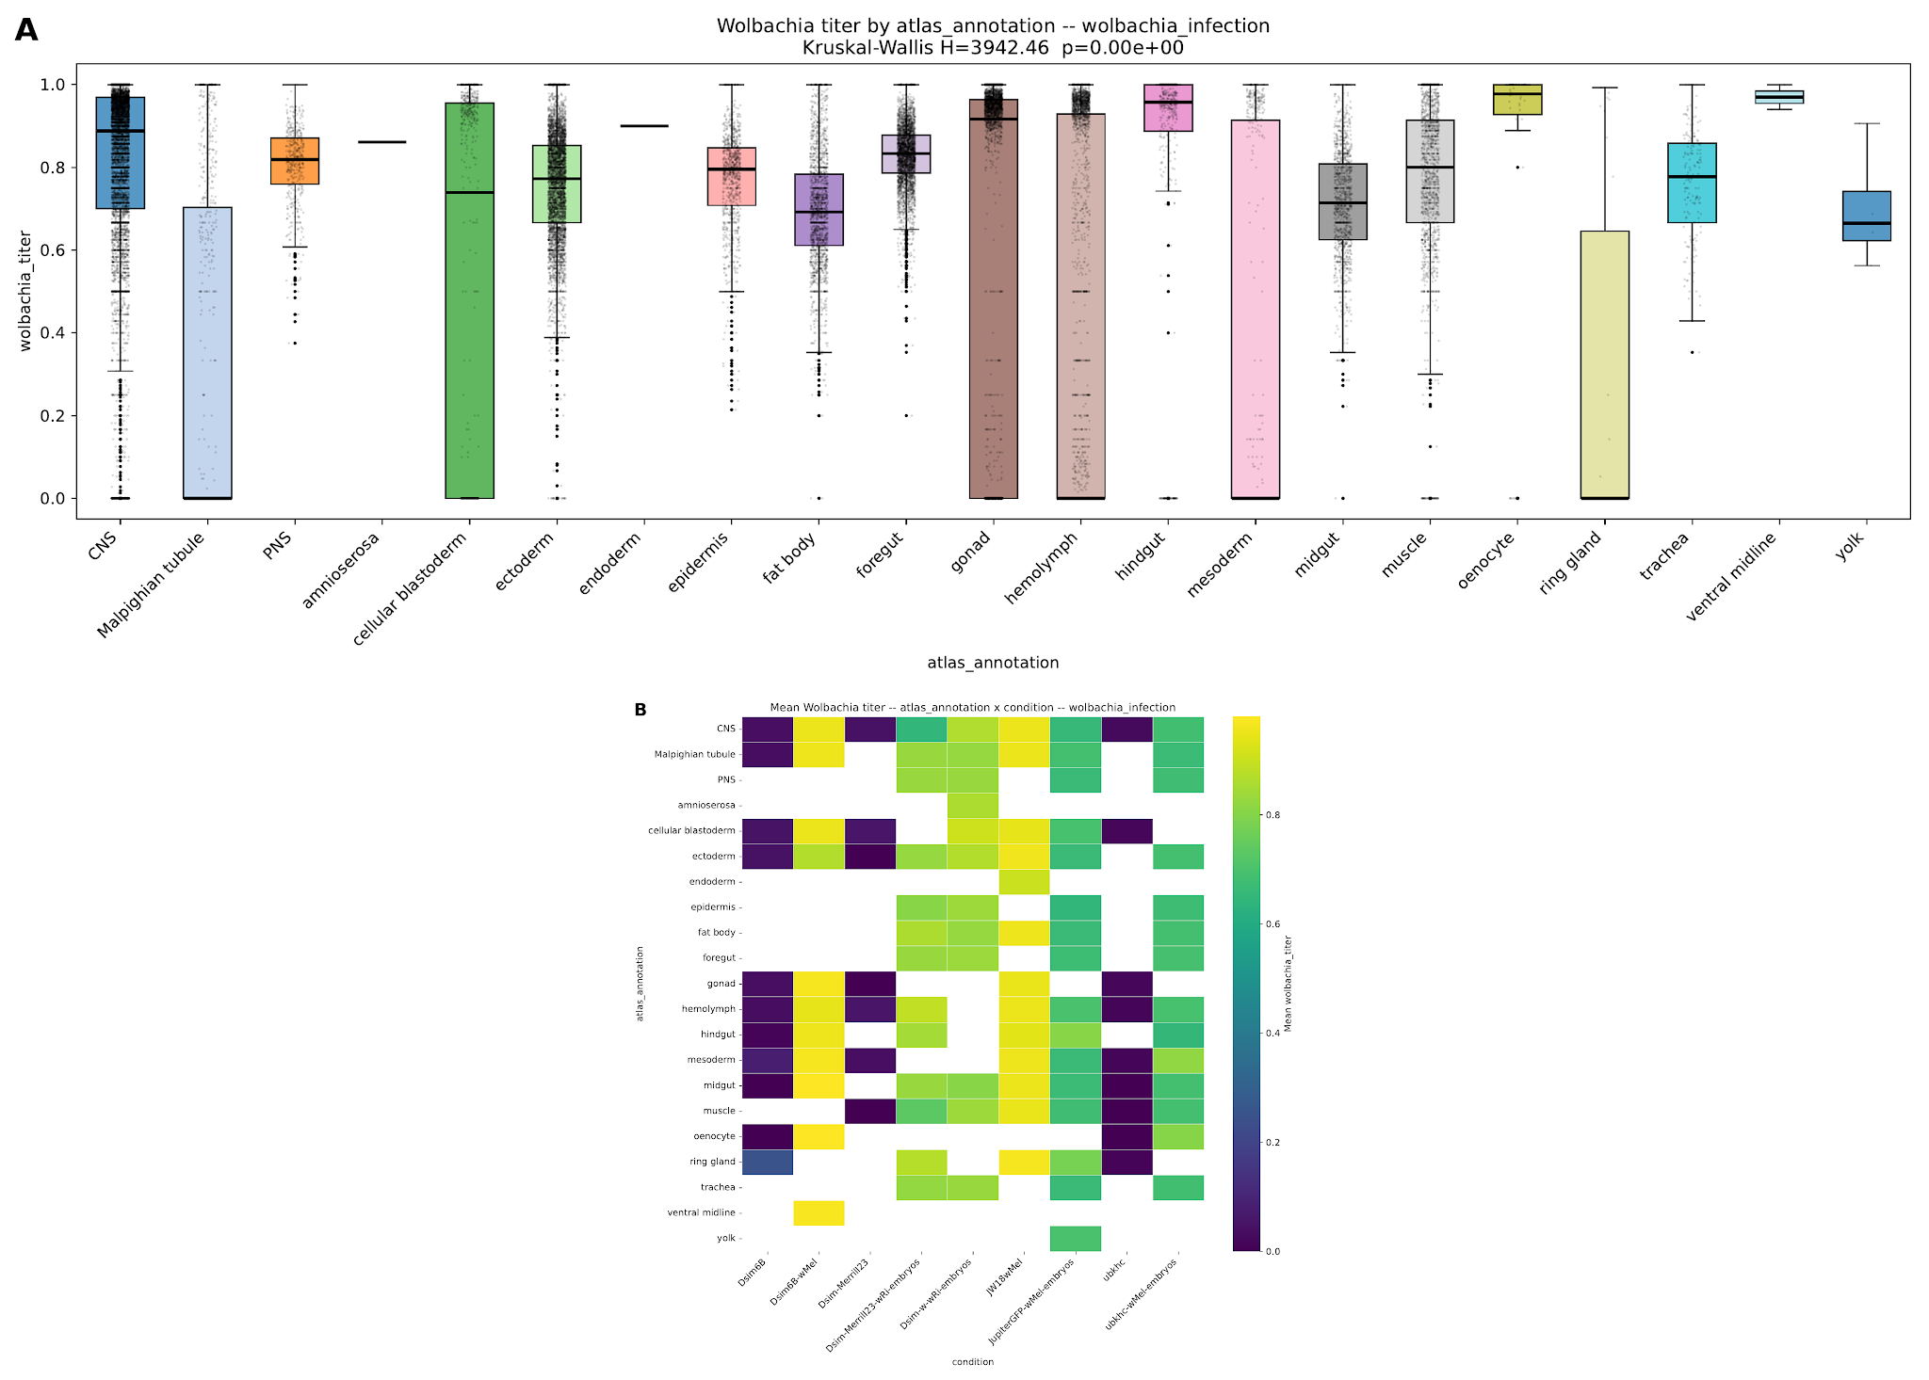
Figure 4. Wolbachia titer by transferred cell type and condition. (A) Distribution of Wolbachia titer across all 35,921 cells, grouped by transferred atlas_annotation (Kruskal–Wallis test, H = 3942.46, df = 19, p < 0.0001). (B) Mean Wolbachia titer for each combination of transferred cell type and condition; blank cells indicate the combination was not observed. ubkhc and Dsim-Merrill23 lost their infections in culture; Dsim6B was cured with doxycycline.

Cells with more Wolbachia are less cell-line-like and express more pro-apoptotic genes within primary cell lines
To ask whether Wolbachia load in early culture relates to the cell-line state, we measured load as the fraction of each cell's UMIs from Wolbachia genes, because the rRNA-based titer saturates near 1 in both D. simulans primary cell lines. wRi-infected D. simulans embryos carried more Wolbachia than wMel-infected D. melanogaster embryos (median 1.9% and 3.9% versus 1.0% and 1.1% of UMIs), and wRi kept more of it after a few weeks in culture (54% and 80% of the embryo load, versus 25% and 31% for wMel), so the Dsim_w primary cell line carried 13 times more Wolbachia per cell than the Dmel_Ubkhc primary cell line (3.2% versus 0.25%). Host species, Wolbachia strain, and load are confounded across the four lineages, so we treat these differences as descriptive. Within each primary cell line, we correlated per-cell load with cell-state scores, controlling for host UMIs and marker-based cell state (partial Spearman; BH-adjusted; combined across lineages by Stouffer's method; Table S13). In three of four lineages, cells with more Wolbachia scored lower for the shared cell-line signature (ρ = −0.11 to −0.24; Dmel_Ubkhc ρ = 0.04; combined p < 10⁻¹⁰) and for OXPHOS genes (ρ = −0.16 to −0.27), and higher for the antimicrobial-peptide program (ρ = 0.09 to 0.23). Load correlated weakly and positively with apoptosis genes in all four lineages (ρ = 0.003 to 0.08; significant in three) and negatively with proliferation in two (ρ = −0.04 and −0.08). The fraction of proliferating cells fell from the lowest to the highest load quintile in every lineage (7.1% to 3.4% in Dmel_JupiterGFP, 3.0% to 1.6% in Dmel_Ubkhc, 12.0% to 9.8% in Dsim-Merrill23, and 0.5% to 0% in Dsim_w). Because load is a ratio to host UMIs, cells with less host transcription score higher, and dividing cells split their bacteria between daughters, so these associations may partly reflect cell activity rather than an effect of Wolbachia. They do not support the idea that heavily infected cells in early culture are the most cell-line-like. The same associations held when we measured load as raw Wolbachia UMIs with host UMIs as a covariate, avoiding the ratio (cell-line signature ρ = −0.10 to −0.14 in three lineages; Dmel_Ubkhc ρ = 0.08). Heavily infected cells instead expressed more pro-apoptotic genes: reaper (ρ = 0.05 to 0.10), sickle (0.03 to 0.09), p53 (0.03 to 0.06), and the effector caspase Dcp-1 (0.05 to 0.08) rose with load in all four lineages (adjusted p < 0.05), and grim in three (0.03 to 0.07), whereas the death inhibitor Diap2, the caspase Drice, and the JNK feedback gene puc did not rise (ρ = −0.03 to 0.02). Two genes did not fit this pattern: the anti-apoptotic Bcl-2 family gene Buffy rose with load (ρ = 0.04 to 0.07; expressed in 3–4% of cells), and the pro-apoptotic Debcl fell in three lineages. These effects were small, and grim and sickle were detected in only 1–11% of cells. Infected cell lines also expressed more reaper and hid than uninfected cell lines of the same species (JW18wMel versus ubkhc, reaper log2 CPM 6.8 versus 1.2 and hid 8.8 versus 5.9; Dsim6B-wMel versus Dsim6B and Dsim-Merrill23, reaper 7.9 versus 3.7 and 4.5 and hid 6.5 versus 3.5 and 4.3), with similar Diap1 (8.2–8.5), although each comparison involves a single infected line.
To test these associations with cell states defined before any Wolbachia data were read, we called three host-only states on one scale per lineage: dividing cells (S-phase or G2/M score above that of expression-matched random gene sets), a cell-line classifier score (out-of-fold logit of a classifier trained on cell-line versus primary-cell-line cells after downsampling to equal depth, excluding cell-cycle, ribosomal, stress, immune, and about 1,600 Wolbachia-responsive genes), and a death-resistance score (mean z of Diap1, Diap2, Buffy, and Bruce minus mean z of reaper, hid, grim, and sickle; Table S15). The classifier separated the two stages almost perfectly (AUC > 0.9999 in every lineage), so no more than 0.1% of primary-cell-line cells scored as line-like, and we tested the continuous score. Within primary cell lines, cells with more Wolbachia UMIs, controlling for host UMIs, scored lower on the cell-line classifier in all four lineages (ρ = −0.01 to −0.21; adjusted p < 10⁻⁷ in three; Stouffer p = 10⁻⁷¹), lower on the cell-cycle score (ρ = −0.01 to −0.18; adjusted p < 0.01 in three; Stouffer p = 10⁻³⁸), and slightly lower on death resistance (ρ = −0.06 to 0.02; adjusted p < 0.001 in Dsim_Merrill23 and Dsim_w; Stouffer p = 8 × 10⁻⁴). Dividing cells carried fewer Wolbachia UMIs than other cells of the same culture after adjusting for host UMIs (0.81-fold in the Dmel_JupiterGFP and 0.88-fold in the Dsim_Merrill23 primary cell lines, 0.81-fold in JW18wMel, and 0.85-fold in Dsim6B-wMel; adjusted p < 0.001; Dmel_Ubkhc primary 0.98-fold, not significant; the Dsim_w primary cell line had only six dividing cells). The infected cell lines also divided less and silenced H99 less often than uninfected cell lines of the same species: 18.6% of JW18wMel and 4.6% of Dsim6B-wMel cells were dividing, versus 47.8% of ubkhc, 33.8% of Dsim6B, and 14.7% of Dsim-Merrill23 cells, and 20% and 38% of infected-line cells expressed no H99 gene, versus 89%, 92%, and 91% of uninfected-line cells. With one infected cell line per species, these differences cannot be separated from other differences between the lines.
We also asked whether Wolbachia could stabilize early culture by limiting the response to dissociation, buffering oxidative stress, or supplying iron or heme, and stated before running the analysis that each would predict less stress signaling with more Wolbachia (Table S16). Every primary cell line raised antimicrobial-peptide, NRF2 redox, and iron and heme programs relative to its embryos, and all but Dsim_Merrill23 raised injury and JAK/JNK genes (Cohen's d 0.9 to 5.0). Across the four lineages, primary-culture load correlated negatively with the rise in injury and antimicrobial programs (ρ = −0.8) but positively with the rise in redox (ρ = 0.8) and iron and heme programs (ρ = 0.2), and none of these reached significance (exact p ≥ 0.33; smallest attainable 0.083). Within primary cell lines, cells with more Wolbachia expressed more, not less, of the antimicrobial-peptide (ρ = 0.10 to 0.23), NRF2 redox (0.03 to 0.13), and iron and heme programs (0.04 to 0.11) in three lineages each, and of the starvation program (0.03 to 0.14) in all four (adjusted p < 0.05; Dmel_Ubkhc showed only the starvation association). In the infected cell lines the antimicrobial association reversed (ρ = −0.26 in JW18wMel and −0.19 in Dsim6B-wMel). Relative to cured Dsim6B, Dsim6B-wMel up-regulated all five detected injury and JAK/STAT genes (mean log2 fold change +1.7), 9 of 13 NRF2 targets, including cnc, Gclc, Gclm, and GstD1 (+1.2), and the starvation genes Thor, InR, and bmm (+1.1), but not iron and heme genes (−0.2). Within cultures and between the two Dsim6B lines, Wolbachia therefore went with more stress signaling, not less.
Wolbachia load did not track the receptor switch in the direction of the cell-line state. Within primary cell lines, cells with more Wolbachia UMIs, controlling for host UMIs, expressed slightly more Egfr (ρ = 0.07 to 0.16 in three lineages, adjusted p < 0.05; Dmel_Ubkhc ρ = 0.01) and had lower switch scores (ρ = −0.05 to −0.15 in the same three lineages; Figure 10C), and the fraction of Egfr-positive cells rose from the lowest to the highest load quintile (24% to 36% in Dmel_JupiterGFP, 5% to 13% in Dsim_Merrill23, and 38% to 60% in Dsim_w). In the JW18wMel cell line the association reversed weakly, with load tracking Pvr, Pvf ligands, and the Spitz-processing genes rho, ru, and Star (ρ = 0.05 to 0.14). Across the four lineages, primary-culture load did not predict the size of the switch (ρ = 0.6, exact p = 0.42, n = 4). The infected Dsim6B-wMel cell line expressed as much Pvr as cured Dsim6B (log2 fold change −0.10; adjusted p = 0.46), and neither line expressed Egfr, but Dsim6B-wMel up-regulated Pvf3 (+2.0), Pvf2 (+0.6), rho (+2.4), and Star (+1.4; adjusted p < 10⁻⁵ for all four) and down-regulated argos (−0.5). Wolbachia therefore appears to raise ligand and ligand-processing genes without changing which receptor the cells express.

Discussion
Considered together, these results suggest that cell lines established from dissociated embryos converge on a shared proliferative program rather than preserving a single embryonic tissue. Embryo samples retained the full range of dissociated embryonic cell types, while every cell line examined here, independent of host species or Wolbachia infection, converged on the same hemolymph-dominated, proliferative profile. Three observations support convergence. Cell lines resembled one another more than embryos from their own stocks (p = 0.016) and correlated less with every embryonic reference tissue (p = 0.016). The differences between primary cell lines and cell lines were shared across four stocks in two species, with 84% of changed genes differing in the same direction in every stock. Most directly, the cells with the highest cell-cycle gene expression in three of four primary cell lines already carried part of the cell-line expression difference, beyond cell-cycle and ribosome genes and independent of sequencing depth, which suggests that proliferation in culture favors this program. The primary cell lines we sequenced are not the ancestors of the cell lines, which were established from the same stocks years to decades earlier, so these data cannot identify the cells that founded the cell lines or distinguish selection of pre-existing cells from later adaptation. The differences between primary cell lines and cell lines also combine the changes of establishment with years of adaptation to culture.
The shared cell-line program suggests three mechanisms that could maintain proliferation in established cell lines. First, the cell lines silenced developmental transcription factors and Hox genes, and the silenced regulators were Polycomb targets in the embryo and remain in Polycomb chromatin in S2 and BG3 cells. Established cell lines therefore appear to keep, rather than erase, the developmental repression laid down in the embryo, while losing the inducible injury, immune, and fat-body programs that primary cell lines switch on. Second, the cell lines silenced grim and sickle, which sit in the H99 pro-apoptotic locus that becomes epigenetically silenced in late embryos (Zhang et al. 2008), and Buffy, a change that could make cells resistant to the apoptotic signals of dissociation and passage. Third, the cell lines replaced EGFR with PVR as their dominant receptor tyrosine kinase while maintaining MAPK target expression and Pvf2 ligand. PVR signaling supports hemocyte survival (Brückner et al. 2004), Pvf2 overexpression drives hemocyte overproliferation (Munier et al. 2002), and oncogenic Ras is an established route to new Drosophila cell lines (Simcox et al. 2008), so an autocrine Pvf2/PVR/Ras-MAPK loop could substitute for the tissue signals, including Dpp, Activin, Wingless, insulin-like peptides, and ecdysone, that the cell lines lost. The single-cell data support this loop only weakly. In primary cell lines, Pvr and Pvf2 rose mainly in plasmatocyte-like cells, and proliferating cells were depleted of Egfr but not enriched for Pvr, so losing EGFR, rather than gaining PVR, distinguishes proliferating cells in early culture. We therefore treat the autocrine loop as a feature of established cell lines rather than a driver of proliferation in early culture. The species difference suggests a refinement of this model. D. simulans cell lines kept less Star than D. melanogaster cell lines, and D. simulans primary cell lines and cell lines expressed less of the tyrosine phosphatases Ptp4E and Ptpmeg although the embryos matched. Without Star, cells make little active Spitz or Keren, which leaves Vein, the one EGFR ligand that needs no processing, as their only EGFR input, and lower phosphatase activity could let PVR sustain MAPK signaling at a given receptor level. Because D. simulans embryos establish cell lines more readily, Star and Ptp4E are candidates for the species difference in immortalization. Only Dsim_Merrill23 had lost Egfr by the primary stage, however, so these data do not show that D. simulans cells leave the EGFR state earlier. Knocking down Ptp4E or Star in D. melanogaster primary cultures, or expressing them in D. simulans primary cultures, would test whether they affect establishment. Measuring H3K27me3 directly in these cell lines (for example by CUT&Tag), and testing whether Pvr knockdown or MEK inhibition slows cell-line growth, would test the Polycomb and PVR hypotheses.
Wolbachia could aid early immortalization by imposing an apoptotic bottleneck. Every cell line here silenced grim and sickle (log2 CPM ≤ 1.3), both of which lie entirely within embryonic H3K27me3 domains, together with Buffy, so escaping H99-driven apoptosis appears to be a shared feature of established cell lines. Within primary cell lines, heavily infected cells expressed more reaper, sickle, grim, p53, and Dcp-1, and infected cell lines expressed more reaper and hid than uninfected cell lines of the same species. Heavily infected cells and the infected Dsim6B-wMel line also expressed more injury, NRF2 redox, and starvation genes, so Wolbachia appears to add to culture stress rather than buffer it, and the infected cell lines contained fewer dividing and fewer H99-silent cells than uninfected cell lines of the same species. If Wolbachia raises pro-apoptotic signaling, cultures with more Wolbachia would eliminate cells that cannot silence these genes more quickly and so enrich early for the apoptosis-resistant cells that can found a cell line. Under this model, Wolbachia aids immortalization at the level of the culture, by strengthening selection, rather than by helping the cells it infects, which fits our observation that the most heavily infected cells were the least cell-line-like. Heavily infected cells in primary cell lines also kept more Egfr, so Wolbachia does not appear to push cells toward the PVR-dependent state of cell lines. The model also fits the species difference: after a few weeks in culture, wRi-infected D. simulans primary cell lines carried 3 to 13 times more Wolbachia per cell than wMel-infected D. melanogaster primary cell lines (1.0% and 3.2% versus 0.25% and 0.33% of UMIs), and the highest-load culture, Dsim_w, had the highest grim, sickle, and reaper expression of the four primary cell lines (log2 CPM 3.2, 3.9, and 6.6). Our data support only the first step of this model. The within-culture associations are small (ρ ≤ 0.10), pro-apoptotic transcripts do not show that more cells die, host species, Wolbachia strain, and load are confounded across the four lineages, and with one culture per stock we cannot relate load to how often cultures immortalize. Three approaches would test the model: staining the existing FISH preparations for cleaved Dcp-1 or TUNEL to ask whether heavily infected cells die more often; following replicate primary cultures from infected and tetracycline-cured flies of the same stock to compare early cell death, H99 silencing, and establishment rates; and comparing the lab's establishment records for infected and uninfected stocks of each species.
This dataset provides little evidence that Wolbachia infection status determines which cell types dominate established cell lines: the same hemolymph-dominated composition was observed in infected cell lines (Dsim6B-wMel, JW18wMel) and uninfected cell lines (Dsim6B, Dsim-Merrill23, ubkhc) alike. Infection was, however, often lost in culture. Of the three lineages whose natural infection entered culture without intervention, two lost it: ubkhc lost wMel and Dsim-Merrill23 lost wRi, whereas JW18wMel kept wMel. Primary cell lines from the ubkhc and Merrill23 stocks remained infected after several weeks in culture (0.3% and 1.2% of UMIs; 99.7% and more than 99.9% of cells with Wolbachia reads), so infection is not lost early in culture as a rule, but we cannot date when the established ubkhc and Dsim-Merrill23 cell lines lost infection. The two infected cell lines were infected in every cell and near saturation (median titer among infected cells 0.95–0.97; 87–93% of cells at or above 0.9), whereas embryos showed graded titers (median 0.67–0.88; 1–41% at or above 0.9; Table S11). Titer was also high after a few weeks in culture: both D. simulans primary cell lines were near saturation (median 0.95 and 0.97; 89% and 95% of cells at or above 0.9), and the JupiterGFP primary cell line (median 0.86; 28%) exceeded JupiterGFP-wMel embryos (0.67; 1%), although it fell below the long-established JW18wMel line (0.95; 93%). With two infected cell lines the embryo-versus-cell-line difference cannot reach significance (the smallest attainable exact p is 0.13), so we treat it as descriptive. Because the primary cell lines are not the ancestors of the cell lines, these values describe separate culture states rather than a trajectory. Finally, the infected Dsim6B-wMel cell line re-expressed reaper and hid and down-regulated growth programs relative to the doxycycline-cured Dsim6B line, the opposite of the apoptosis silencing seen across all cell lines. This would suggest that Wolbachia partly counteracts the growth program of immortalized cells, which could put infected cells at a disadvantage in long-term culture. The two lines, however, differ in cell identity and white expression, and the cured line carries possible doxycycline effects, so an independently cured Dsim6B-wMel subline would provide a cleaner comparison.

Supplementary figure
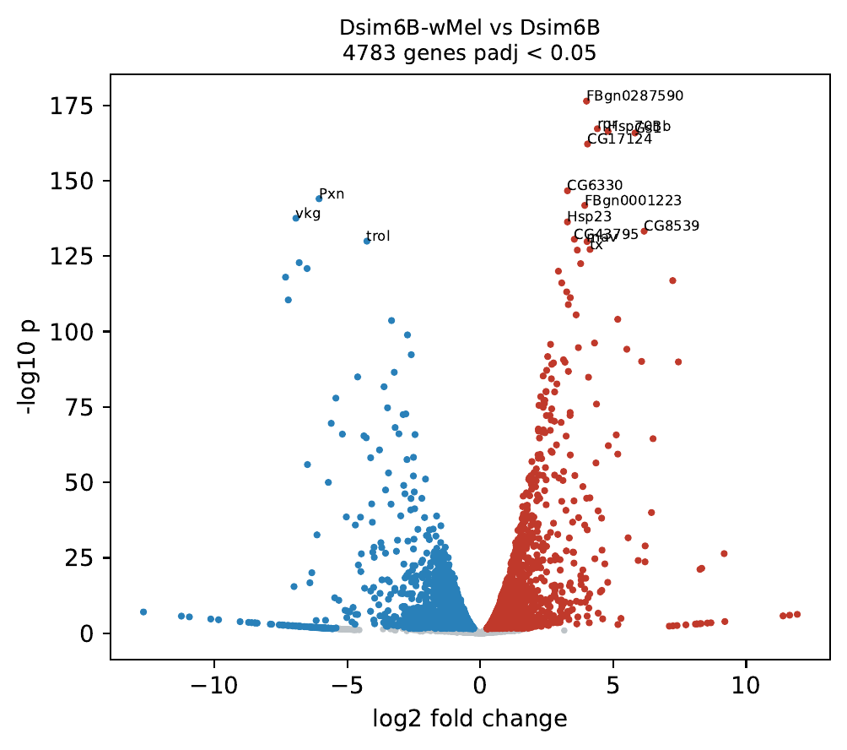
Figure S1. Pseudobulk differential expression between Dsim6B-wMel and Dsim6B (two libraries each; PyDESeq2, design ~ infection). Red, higher in Dsim6B-wMel; blue, higher in Dsim6B; adjusted p < 0.05.

Supplementary tables
Table S1. Sample summary: cells, median UMIs, stage, lineage, Wolbachia UMI fraction, and same-stage nearest-neighbor fraction (results/pseudotime/infection/sample_summary.csv; results/pseudotime/*/figures/knn_stage_mixing_*.csv).
Table S2. Pseudobulk differential expression for every contrast, with per-lineage log2 fold changes and direction agreement (results/pseudotime/de/de_*.csv, lineage_consistency_*.csv).
Table S3. GSEA results for every contrast (results/pseudotime/de/gsea_*.csv).
Table S4. Marker-state and flag fractions per sample, and stage tests (results/pseudotime/cell_states/state_fractions_by_sample.csv, composition_tests.csv).
Table S5. Rank test for primary-cell-line subsets (results/pseudotime/cell_states/precursor_rank_test.csv).
Table S6. Pvr, Pvf2, MAPK-target, and proliferation correlations per sample (results/pseudotime/cell_states/pvr_mapk_by_sample.csv).
Table S7. Polycomb marking per gene, trend test, and GO enrichment of switched-off genes (results/pseudotime/silencing/gene_marks.csv, h3k27me3_trend.csv, go_off_*.csv; results/pseudotime/mechanisms/genes_off_in_all_lines.csv).
Table S8. Dsim6B-wMel versus Dsim6B differential expression and GSEA (results/pseudotime/infection_de/).
Table S9. Shannon diversity and tissue-specificity tests (results/atlas_stats/diversity_tests.csv, tissue_specificity*.csv).
Table S10. Pseudobulk correlation permutation test and same-stock embryo ranks (results/atlas_stats/correlation_permutation.csv, parent_rank.csv).
Table S11. Wolbachia titer among infected cells by condition (results/atlas_stats/titer_by_condition.csv, titer_tests.csv).
Table S12. Culture-emergent species differences: candidates higher in D. simulans or D. melanogaster, and all genes (results/pseudotime/species_candidates/candidates_Dsim_high.csv, candidates_Dmel_high.csv, species_gap_all.csv).
Table S13. Wolbachia load by lineage and stage, within-culture partial correlations with cell-state scores and apoptosis genes (fraction and count load measures), and load quintiles (results/pseudotime/wolbachia_load/load_by_sample.csv, within_culture.csv, within_culture_combined.csv, quintiles.csv, quintiles.pdf).
Table S14. Egfr-to-Pvr switch: receptor classes and pseudobulk expression per sample, stage tests, ligand co-expression and ligand-receptor scores, identity of Pvr-positive cells, proliferative cells, MAPK readouts, species contrasts, and Wolbachia load (results/pseudotime/rtk_switch/: switch_by_sample.csv, switch_stage_tests.csv, autocrine.csv, lr_by_state.csv, identity.csv, identity_states.csv, proliferative.csv, mapk.csv, species_switch.csv, species_de.csv, wolbachia_within.csv, wolbachia_by_class.csv, wolbachia_quintiles.csv, wolbachia_culture_level.csv, wolbachia_infected_vs_cured.csv).
Table S15. Pre-specified host-only cell states (dividing, cell-line classifier score, death resistance) and their association with Wolbachia load (results/pseudotime/wolbachia_states/: states_validation.csv, classifier_auc.csv, tests_continuous.csv, tests_binary.csv, tests_primary_combined.csv, load_vs_states_primary.pdf).
Table S16. Culture stress programs: embryo-to-primary shifts, culture-level and within-culture associations with Wolbachia load, and Dsim6B-wMel versus Dsim6B (results/pseudotime/culture_stress/: modules_used.csv, shift_embryo_to_primary.csv, culture_level.csv, within_culture_modules.csv, within_culture_genes.csv, infected_vs_cured.csv, culture_stress.pdf).

References to verify
Brückner K, Kockel L, Duchek P, Luque CM, Rørth P, Perrimon N (2004). The PDGF/VEGF receptor controls blood cell survival in Drosophila. Dev Cell 7:73–84.
Munier AI, Doucet D, Perrodou E, et al. (2002). PVF2, a PDGF/VEGF-like growth factor, induces hemocyte proliferation in Drosophila larvae. EMBO Rep 3:1195–1200.
Simcox A, Mitra S, Truesdell S, et al. (2008). Efficient genetic method for establishing Drosophila cell lines unlocks the potential to create lines of specific genotypes. PLoS Genet 4:e1000142.
Zhang Y, Lin N, Carroll PM, et al. (2008). Epigenetic blocking of an enhancer region controls irradiation-induced proapoptotic gene expression in Drosophila embryos. Dev Cell 14:481–493.
Kharchenko PV, Alekseyenko AA, Schwartz YB, et al. (2011). Comprehensive analysis of the chromatin landscape in Drosophila melanogaster. Nature 471:480–485.
Lee JR, Urban S, Garvey CF, Freeman M (2001). Regulated intracellular ligand transport and proteolysis control EGF signal activation in Drosophila. Cell 107:161–171.
Tsruya R, Schlesinger A, Reich A, Gabay L, Sapir A, Shilo BZ (2002). Intracellular trafficking by Star regulates cleavage of the Drosophila EGF receptor ligand Spitz. Genes Dev 16:222–234.

